Executive Compensation
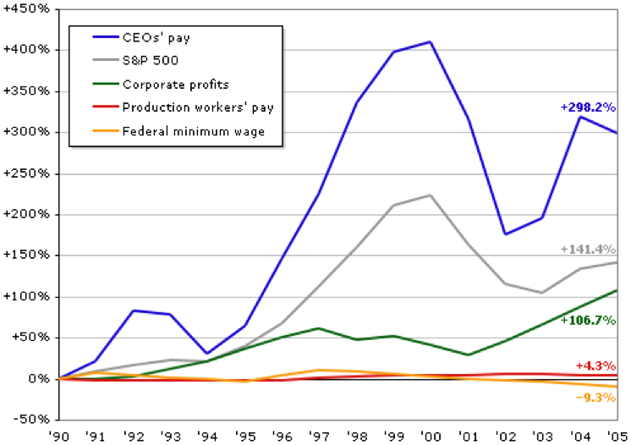

The above chart shows the growth of the average CEO pay over the period 1990 to 2005. The head of a typical public company made $ 9.7 million dollars in 2011. There are many who see too weak a link between CEO pay and performance. Others object to the gap between executive compensation and the average worker. In your research this week, explore either or both of these issues.
The answer should have two sources, a brief synopsis of what how each of the sources informs the issue, the veracity of each source, and the questions that it raises or answers.

