Part 1
1. To get the best deal on a CD player, Tom called eight appliance stores and asked the cost of a specific model. The prices he was quoted are listed below:
$ 298 $ 125 $ 511 $ 157 $ 231 $ 230 $ 304 $ 372 Find the Standard deviation

2. When investigating times required for drive-through service, the following results (in seconds) were obtained. Find the range, variance, and standard deviation for each of the two samples, then compare the two sets of results.
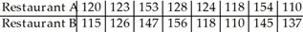

3. A company had 80 employees whose salaries are summarized in the frequency distribution below. Find the standard deviation. Find the standard deviation of the data summarized in the given frequency distribution.
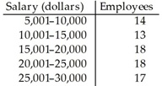

4. The manager of a bank recorded the amount of time each customer spent waiting in line during peak business hours one Monday. The frequency distribution below summarizes the results. Find the standard deviation.
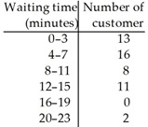

5. The heights of a group of professional basketball players are summarized in the frequency distribution below. Find the standard deviation.
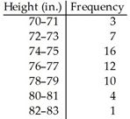

Part II
1. 50, 33, and 48 students are selected from the Sophomore, Junior, and Senior classes with 496, 348, and 481 students respectively. Identify which type of sampling is used and why

2. The name of each contestant is written on a separate card, the cards are placed in a bag, and three names are picked from the bag. Identify which type of sampling is used and why

3. An education expert is researching teaching methods and wishes to interview teachers from a particular school district. She randomly selects ten schools from the district and interviews all of the teachers at the selected schools. Does this sampling plan result in a random sample? Simple random sample? Explain.

4. A polling company obtains an alphabetical list of names of voters in a precinct. They select every 20th person from the list until a sample of 100 is obtained. They then call these 100 people. Does this sampling plan result in a random sample? Simple random sample? Explain.

5. The personnel manager at a company wants to investigate job satisfaction among the female employees. One evening after a meeting she talks to all 30 female employees who attended the meeting. Does this sampling plan result in a random sample? Simple random sample? Explain.

