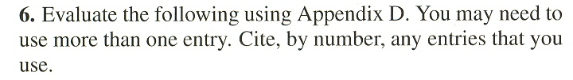
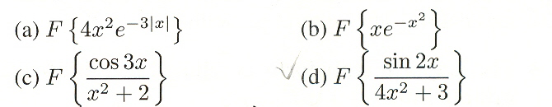

(The problems are from Fourier Transform. Please solve for only part (a) & (c). Thank you.)

Appendix D: (Next Pages)


