Hall, Inc. agrees to lease equipment from White Inc. for 10 years for $50,000 at the end of each year. The equipment has a fair value of $350,000 and an estimated useful life of 10 years. The lease includes a guaranteed residual value of $20,000. In addition to the lease payments, Hall will pay $10,000 per year for a maintenance agreement. Hall can finance this lease with its bank at a 12% rate. The lessor's implicit interest rate is 10%. Use the present value factors from Appendix I near the end of your text to perform any necessary present value calculations. What is the entry to record this lease on Hall's books?
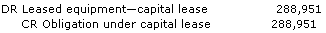
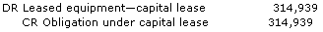
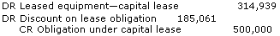
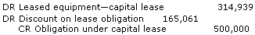
Hall, Inc. agrees to lease equipment from White Inc. for 10 years for $50,000 at the end of each year. The equipment has a fair value of $350,000 and an estimated useful life of 10 years. The lease includes a guaranteed residual value of $20,000. In addition to the lease payments, Hall will pay $10,000 per year for a maintenance agreement. Hall can finance this lease with its bank at a 12% rate. The lessor's implicit interest rate is 10%. Use the present value factors from Appendix I near the end of your text to perform any necessary present value calculations. At the end of Year 1, Hall will make a payment of $60,000. Which one of the following entries will properly record this payment?
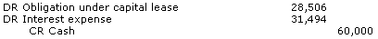
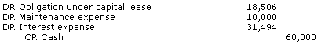
Hall, Inc. agrees to lease equipment from White Inc. for 10 years for $50,000 at the end of each year. The equipment has a fair value of $350,000 and an estimated useful life of 10 years. The lease includes a guaranteed residual value of $20,000. In addition to the lease payments, Hall will pay $10,000 per year for a maintenance agreement. Hall can finance this lease with its bank at a 12% rate. The lessor's implicit interest rate is 10%. Use the present value factors from Appendix I near the end of your text to perform any necessary present value calculations. At the end of Year 1, Hall will make a payment of $60,000. How much straight-line depreciation expense will Hall record for Year 1?
$29,494
$30,723
$31,494
$35,000
Burrell Corporation leases a building from Bennett Corporation for 10 years for $50,000 at the end of each year. The building has a fair value of $350,000 and an estimated useful life of 25 years. In addition to the lease payments, Burrell will pay $10,000 per year for general maintenance. Burrell can finance this lease with its bank at a 12% rate. The lessor's implicit interest rate is 10%. Use the present value factors from Appendix I near the end of your text to perform any necessary present value calculations. The Burrell lease is a(n):
capital lease because the lease term is more than 75% of the life of the asset.
capital lease because the lease value is 90% or more of the fair value of the asset.
operating lease because the asset reverts to the lessor at the end of the lease.
operating lease because the lease value is less than 90% of the fair value of the asset.

Burrell Corporation leases a building from Bennett Corporation for 10 years for $50,000 at the end of each year. The building has a fair value of $350,000 and an estimated useful life of 25 years. In addition to the lease payments, Burrell will pay $10,000 per year for general maintenance. Burrell can finance this lease with its bank at a 12% rate. The lessor's implicit interest rate is 10%. Use the present value factors from Appendix I near the end of your text to perform any necessary present value calculations. Burrell should record which one of the following entries to journalize the first payment on the lease?

