Communication is key to team success in Virtual Team. But communication gets more complicated as more people are involved in the process. As the number of people increases, the number of communication paths increases too. The number does not increase additively, as the number of people increases, the number of communication paths increases multiplicatively.
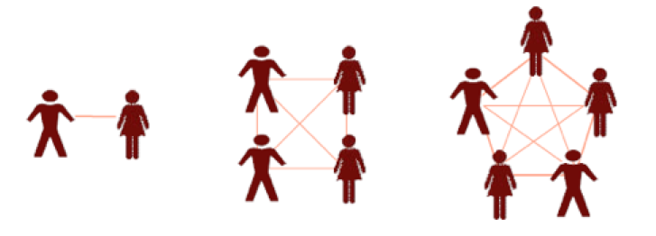
The above diagram shows that two people have only one path of communication. Four people have six paths and five people have 10 paths of communication. Ten people would have 45 paths if every person talked to every other person. The more communication paths there are, the more time spent communicating and the more opportunities there are for communication problems.
Your thoughts?

