1. Suppose that the true relationship between y, x, and z is y_{i} = β₀ + β₁x_{i} + β₂z_{i} + u_{i}, where
economic theory predicts β₀ > 0, β₁ < 0, and β₂ < 0. U_{i} is a random error with an expected
value of zero. The following sample model has been proposed: 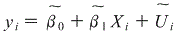
Answer the following:
a) Show than (beta one tilda)
is a biased estimator of and that the bias is equal to
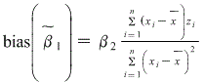
Note: if you can’t see the equation above. In the numerator it says xi minus x bar times zi and in the denominator it says xi minus x bar squared.
﻿b) Let ( beta one hat) be the multiple regression estimate from y on x and z, would you
expect 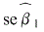 (standard error beta one tilde) or 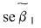(standard error beta one hat)
to be smaller? Explain.

c) The following sample model has been estimated: 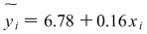 The sign of the
coefficient on x_{i} is the opposite of what economic theory predicts. Can this be explained
by the omission of z_{i}? What is the implied sign for the correlation between x_{i} and z_{i}?
Explain your answer.

