The u-tube shown has a cross-section of 1 cm^2. It contains mercury to the shown levels. The pressure above the the mercury is 750 torr. The left side is sealed off. The right side is is pumped such that the pressure is approximately zero. How are we supposed to calculate how far the mercury level falls on the right hand side of the tube and the final pressure on the left hand side of the tube.
N.B Temperature is constant
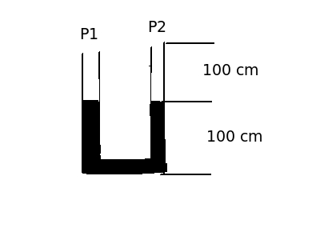
Thanks

