1.Given the situation described, identify the type of sampling involved. At a newspaper office, staffers are classified by the department in which they work. Then random samples from each department are taken.
a. random sampling
b. systematic sampling
c. convenience sampling
d. stratified sampling
e. cluster sampling
3. Given the histogram below, create a grouped frequency distribution

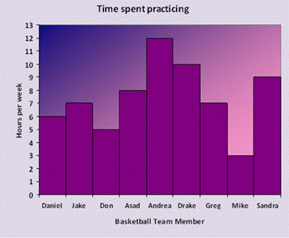

5. The number of surfer’s special burritos served was sampled during a lunch period 11:00 a.m. – 2:30 p.m. at a taco shop on a weekday. Below is the sample:
41 63 39 56 46 55 38 66 41 48
60 57 48 31 71 56 60 39 52
Construct a stem and leaf plot of the data.

6. Below are the home states of 21 college professors.
New Jersey Ohio Michigan South Carolina Nebraska
South Carolina Ohio South Carolina Pennsylvania Michigan
Georgia New Jersey Wisconsin Georgia Ohio
Florida Georgia New Jersey South Carolina Wisconsin
Pennsylvania
i. Make a frequency table using these 9 states:
Florida
Georgia
Michigan
Nebraska
New Jersey
Ohio
Pennsylvania
South Carolina
Wisconsin
ii. What is (are) the mode(s)?
iii. Does it make sense to talk about the average for this data? Why or why not?
iv. Using your frequency table draw a pie chart to display the distribution of home states by filling in the following table:
Home State | Frequency | Percentage of total | Measure of Central Angle (in degrees)
Florida
Georgia
Michigan
Nebraska
New Jersey
Ohio
Pennsylvania
South Carolina
Wisconsin

Given the diagram below, find P upside down U Q. Write in correct set notation.
