CHAPTER 2 Supporting Families Around Issues of Attachment
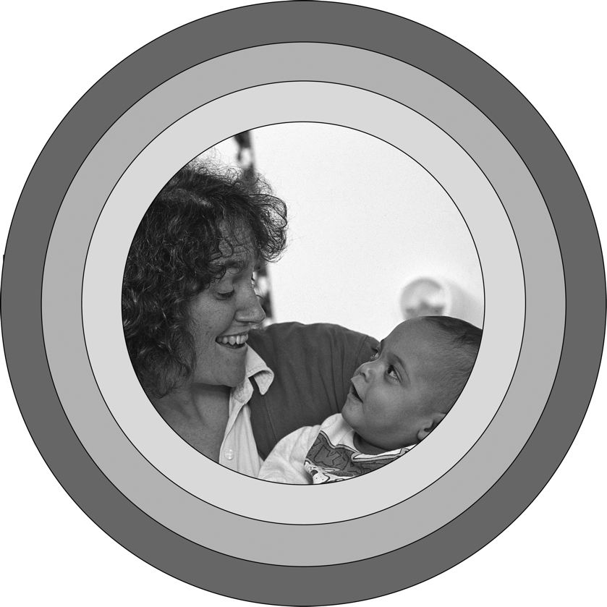
In this chapter you’ll discover …
♦ Why attachment is important
♦ What helps babies develop trust
♦ How parents show they are attached to their baby
♦ How babies show they are attached to their parents
♦ Your role in attaching to babies and supporting their attachment to family
♦ How child care affects attachment
♦ The difference between being an infant-care teacher and being a parent
What is attachment, and why is it important? Why should early childhood educators in general and infant-care teachers in particular be concerned about attachment? Attachment is a lasting emotional relationship that begins to develop in infancy and serves to tie the infant to one or more people in his or her life. It is a two-way process—adults (usually parents or other family members) attach to infants, and infants attach to adults. This two-way process results in a significant relationship. Attachment is a lifelong process that starts in the first year of life and carries throughout the life span. The first early attachment sets the tone for a child’s development and defines some of the issues that he or she will carry into adulthood. This chapter focuses on attachment in infancy and the issues and implications for early care and education professionals working with families.
Although attachment is an emotional process that we associate with “the heart,” other processes engaging the brain are also involved. Healthy attachment provides the foundation for later intellectual development, according to research being done on the brain. The positive nurturing experiences associated with attachment produce hormones called neurotransmitters that give the infant a sense of well-being. This sense of well-being reinforces certain pathways in the brain, which leads to mental growth. On the other hand, children who have attachment issues or worse, no attachment figure(s), lack a sense of security and experience stress, which has a detrimental effect on the brain’s development. Bruce Perry (2002; 2006) in his writings and lectures talks about the chemicals that wash over the brain when babies experience some of the results of lack of attachment, like abuse or neglect.
With school readiness receiving so much widespread attention in the early care and education field, some people think the main message from the brain research is that academic teaching should start early. To the contrary, the real message is the important role that social-emotional development plays in intellectual development. In a new journal published by the International Mind, Brain, and Education Society, Immordino-Yang and Damasio (2007) make an excellent case for emotional processes profoundly affecting learning, attention, and memory. Although they focus on neuroscience and education, and not on infants, attachment is the foundation of the emotional processes they write about. They say that feelings provide an “emotional rudder” to guide judgment and action. That’s one of the reasons that this book focuses in on social-emotional development throughout and starts right off with attachment the basis for early social-emotional development. It’s important for early childhood educators and the families they work with to recognize the role that social-emotional development plays in the lives and development of children.
A short article in Time brings this point home further (Park, 2007). In 2006 parents spent $200 million on Baby Einstein videos to help their babies get ahead intellectually. Yet in a study done at the University of Washington, researchers found that for every hour babies spent watching the videos, they understood an average of seven fewer words than the babies who had no exposure to the videos. The parents of the video-free babies apparently followed the advice of the American Academy of Pediatrics, which recommends that parents keep babies under two away from screens and just interact with them instead. Those interactions are likely to result in stronger, healthier attachment.
Here’s another example of how attachment contributes to cognitive development in infants. When children feel secure, they are freer to explore the environment around them. Watch a group of babies in a playroom. You’re bound to see some exploration as the ones who are mobile go looking to see what’s there. If these babies get too far from their infant-care teacher or become startled, they head back to touch base, get a little hug, and gather up their courage to move out again. The greatest explorers are usually the ones who are securely attached. According to Ainsworth’s research (1977, 1978) secure attachment can be easily seen in the behavior of infants who are separated from their parents and then reunited with them. Attachment is a matter of trust, which is the subject of the next section.
ATTACHMENT AND TRUST
The basis of healthy care and education is social-emotional development and the basis of that is attachment comes from a synchronous relationship, which grows from a number of synchronous interactions. Here’s what a synchronous interaction looks like, whether the adult in the scene is the baby’s parent, a center-based infant-care teacher, or a family child care provider.
The adult is bent over a 3-month-old baby who is lying on her back in a play area. The adult is expressionless. The baby rounds her mouth and lets out a breathy sound while reaching out her arms. The adult responds by widening her eyes, rounding her own mouth, and imitating the sound. She reaches for the baby’s hands and holds them in her own. The baby pulls her hands away, kicks her feet, and widens her own eyes in imitation of the adult. The adult smiles. The baby smiles back. The adult keeps smiling, makes clucking noises, and claps her hands. The baby turns away. “Oh, that was too much for you,” responds the adult, quieting her activity. The baby looks back. The adult smiles. The baby smiles, then arches and reaches. “You want up?” the adult asks, reaching out her arms to the child.
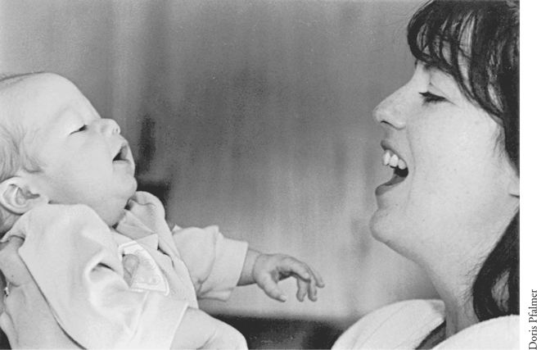
The two are “in sync” with each other.
These two are “in sync” with each other. The adult is sensitive to the baby’s signals and reads the turning away as a need to tune out, not a personal rejection of her. The baby knows how to “light up” the adult’s face. The adult knows how to “turn on” the baby. The two are good together. If they are not already attached, they are becoming attached.
Babies become attached when people in their lives are sensitive and responsive. That means that they pay attention to the baby’s signals and read them accurately, responding readily and appropriately. Adults practice being responsive when they play with babies, as in this scene. They also meet needs by reading babies’ cues and responding in a timely fashion with feeding, for example. Both play and meeting needs contribute to the development of attachment.
Imagine yourself a very young baby, lying asleep in a crib. You open your eyes—suddenly you’re wide awake. You see nothing except a blur of light—there are no objects, no movement within your visual range. You feel a very uncomfortable sensation in your midsection. You squirm around. Changing position doesn’t help. Suddenly you feel desperate. The sensation in your midsection takes over your whole body. You squeeze your eyes shut tight and open your mouth wide. Into your ears comes a piercing sound. You don’t know that it’s your own cry. You only know that something is terribly wrong, and your whole being reacts to it. Your heart pounds, your face burns, and you scream in agony, then gasp for breath, only to start screaming again once you get your lungs full. You’re like this for what seems an eternity but is actually less than 2 minutes. You feel something touch you. You open your eyes and find something very distinctive and vaguely familiar in front of the blur of light that was all that was there before. The something moves in a way that makes you feel comfortable. As you pause for breath, you hear another sound—not the high, agonized one of before, but a soft, soothing one. You feel a blanket of pleasure surround you, providing immeasurable relief, and, true to your most cherished hope, you find yourself lifted in the air out of the loneliness—the isolation—and snuggled into a pair of warm arms. You’re basking in the glow of the feelings of this, when—wonder of wonders—something familiar touches your cheek. You jerk toward the something, manage to get your mouth around it, and begin sucking. A warm, sweet sensation floods your mouth and you’re in heaven.
Imagine now a different scene where the hungry baby wakes up and doesn’t have to signal her needs because the adult is right there with her and feeding occurs immediately, before the baby even cries.
These two scenes illustrate how needs, attachment, and trust all come in a bundle in the beginning of life. The scenes are slightly different. In the first one, the infant wakes up alone and must let the adult know about the need for food and comfort. In the second scene, the infant wakes up in physical contact with the adult, who anticipates the needs before crying occurs.
You may prefer one scene over the other—you may actually feel critical of one of the scenes. However, both of these patterns of relating to the needs of the very young infant lead to a healthy attachment, one that serves both the individual and the culture. It’s important to remember that attachment patterns are related to parental values and goals (Chang, 1993; Gonzalez-Mena, 1997, 2004, 2008). Parents rear their children to fit the world as they perceive it. (See Chapter 6 for more on this subject.)
Attachment is vital. It is a means of ensuring survival of the child and also of the species (Bowlby, 2000). It creates the caring (the feeling) that motivates the action of giving care. It ensures that nurturing and protection will be provided to the relatively helpless infant. But beyond physical survival, the first attachments provide the basis for all future relationships.
If the infant finds that when needs arise they are met with reasonable promptness, as in the two prior scenes, he or she comes to see the world as a welcoming place. A sense of trust grows from fulfillment and satisfaction in the first year of life. Infants who are left screaming for long periods, gripped in the agony of hunger pangs, come to see the world as an unfriendly place. They find that they can’t trust anyone to take care of them. If they give signals and no one responds, they see themselves as powerless and the world as cold and hostile. When these children grow out of infancy, they continue to view the world with distrust.
This early issue of developing trust versus mistrust was originally defined and described by Erik Erikson (1963), who sees life as a series of what he calls psychosocial dilemmas to be resolved (see Figure 2.1).
Trust is a lifelong issue for all of us. However, children who develop a sense of distrust in infancy grapple with the issue more intensely than others. Some of these children are left with unresolved trust issues; others successfully deal with the problem if the situation changes and those around them become more responsive and meet their needs more promptly. Children with unresolved trust issues often reach adulthood still seeking the early caregiver who left their needs unmet. Because it is never too late to resolve trust issues, some adults seem continually to choose to connect to people who treat them much as their early caregiver(s) did. They put themselves back into their infant situation, to perhaps give themselves another chance to relive the situation and manage a different outcome. The human being is very resilient! Continually seeking their early caregiver later in life may not be necessary for those children who find a warm, nurturing person to whom to attach in their early care and education program. According to Bruce Perry, a firm, healthy attachment is one way to get children through hard times in their lives with less damage to their brain development and therefore to their social-emotional and cognitive development (Perry, 2006).
Figure 2.1 Erikson’s psychosocial stages of development
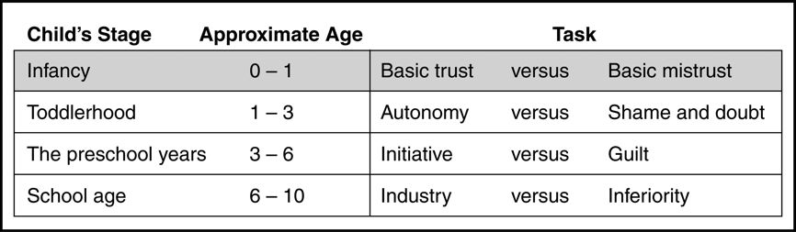
Source: From Erikson (1963).
Attachment is a powerful process—and it seems that even a little goes a long way. Look at studies of survivor types—children who manage to cope and live a productive life in spite of factors in their early years that work against that. The one thing that all these survivor children have in common is a person they could attach to sometime in their first year—even though it might not have been an ideal attachment or a long-lasting one. Emmy Werner, a developmental psychologist, did classic research on resiliency over the last 40 years. Her findings show that attachment in the early years with a caregiver who had predominantly positive interactions with the child acts as a protective factor (Werner, 1984, 1995, 2000; Werner & Smith, 1992). These findings are important for early care and education practitioners to know about, because they focus on the protective factors that can make a difference in children’s lives. In fact, you could be the person who makes the difference in a child’s life.
Strengthening Families Through Early Care and Education is a research project that has identified exemplary family-support programs which show that staff in child care centers and other early education programs can make a difference. Using a “protective factors” framework, the project documents how exemplary programs reduce abuse and neglect. The idea is that programs can intentionally strengthen families while serving their children. One of the protective factors occurs when staff works to build trusting relationships with parents and offers support to them when they are going through difficult periods. That kind of relationship, which can be a type of attachment, is different from what staff provide to children (www.cssp.org/doris_duke, accessed June 20, 2007).
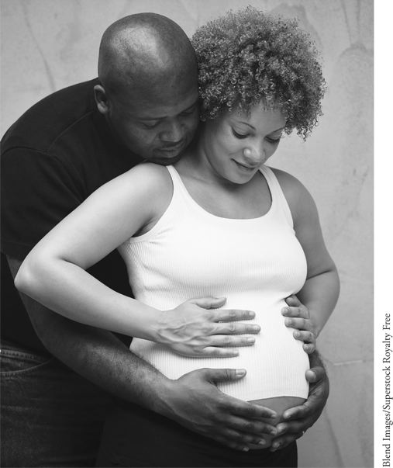
Attachment may begin prenatally, as parents begin to relate to their visions of the growing fetus.
HOW ATTACHMENT OCCURS
There are many different ways of getting attached to infants and older children, depending on the individual and the culture. Although attachment, like love, can’t necessarily come on command, there are certain factors in infant programs that make it more likely to occur. It might be easier to describe the factors that work against it. Imagine a large room in an infant center with a number of babies of different ages and adults there to care for them. The adult/child ratio is within the funding standards—one adult to three children. But the size of the group is big, and there is a chaotic feeling in the room. One child just had his second birthday, and one of the infant-care teachers is getting him ready to move to the classroom in the next building where the two-year-olds are housed. He is protesting loudly. Another screaming child is a 9-month-old who is just getting moved up from the baby room today. What’s wrong with this picture?
According to Ron Lally (1995) three important factors—group size, primary care, and continuity of care—make a big difference in whether relationships grow between adults and the infants in their care. Group size is important. Babies get lost in large groups. Primary care and continuity of care are two other factors that affect whether children form attachments in out-of-home care. Primary care means that, even if there are six, eight, or nine in the group, each caregiver has primary responsibility for only a small number of children—two or three—four at the most. Continuity of care means that children stay with their small group and their primary caregiver, whenever possible, for several years. They don’t move to a new room, new group, and new infant-care teacher whenever they reach a new stage or have a birthday.
These ideas have been tried and tested for the last 60-plus years in Budapest, Hungary, where a pediatrician theorist and researcher named Emmi Pikler started an orphanage for children under three years of age after World War II at the request of the Hungarian government. Pikler was greatly concerned about attachment, and she not only set up the program to support the forming of attachments, but she trained the staff very carefully in exactly how and to what extent to promote this. The program, now called the Pikler Institute, is still running today under the directorship of Pikler’s daughter, Anna Tardos, who continues to carry on her mother’s research. Ideas from Pikler’s approach were brought to the United States back in 1956 by Magda Gerber, who ran parenting groups for years and whose program, Resources for Infant Educators (RIE), is still being carried on.
Pikler’s ideas about attachment are useful today to infant-care teachers as well. She stressed in her training that this was a special kind of attachment—one that gave the children enough security to develop well and function optimally, but was not so strong an attachment that moving into an adoptive family—or back to their own—would devastate the children when the ties with the caregiver in the Institute were cut (David & Appell, 2001).
Attachment, according to Pikler, grew during the one-on-one times when the primary caregiver was able to be intimate and uninterrupted with her primary children. Those times come about during the essential activities of daily living, such as feeding, diapering, dressing, bathing, and grooming.
Becoming attached to someone else’s baby is delicate business. Earlier I said that you may be the protective factor in a child’s life. You may be the one that makes a difference. That’s a heady thought and needs some serious consideration. Some people who go into early care and education have a tendency to rescue children from their parents. This is a stage many pass through. It is important to recognize those tendencies in yourself and set them aside. If you look down on parents, you can’t support them, and it’s your job to be supportive. Watch out that you don’t find yourself in competition with the family for the child’s affection. Be professional at all times, but realize that professional in this profession means warm and caring. Be close and attentive, but also be aware of keeping an optimum distance in your attachment to a child. Optimal closeness should be the parents’ goal, not yours. The child’s attachment to the family is and should be a lot closer than your attachment to the child. The child’s past, present, and future is in the family, not with you. Your attachment is important, but it’s also temporary. If it is too strong, both you and the child will suffer when you separate, as you are bound to do eventually.
ATTACHMENT BEHAVIORS
Attachment can be observed in adults and babies alike. There are certain sets of behaviors that indicate attachment is forming or is already fully established.
Signs of Attachment in Parents
Some parents show signs of attachment right away. They’re smitten with their babies. They feel close to their offspring. They find parenting pleasurable—even the hard and frustrating parts. One mother recalls how her whole life changed when her first baby was born. Suddenly she became important to someone. Her baby depended on her. She had a new interest in world news because it seemed important to make the world a safe place for her baby to grow up in (Gonzalez-Mena, 1995). Not all parents go through such a transformative process, but some do.
Some cultural rituals are related to attachment. Giving a name to the baby and calling him or her by that name is a way of acknowledging the child as an individual. Buying possessions for the new baby is also a way of recognizing individuality and personhood. These are so expected that they don’t seem to relate to attachment, but when they don’t occur, it can be a sign that something is wrong with the attachment. Be careful though about judging across cultures. Attachment behaviors may look quite different.
Signs of Attachment in Infants
Babies take longer to show signs of attachment, although careful research shows that signs exist from birth. Babies just a few hours old can distinguish their mother’s smell and her voice, for example (Cernoch & Porter, 1985; DeCasper & Fifer, 1980). Before long, babies begin to act differently around their primary caregiver (who may or may not be the mother). They may be more animated, less fussy, more interested and alert.
Eventually some babies begin to show distress when someone they don’t know arrives in their field of vision. The distress may accelerate if the stranger approaches. This stranger anxiety shows that the baby can distinguish between the person(s) he or she is attached to and others.
However, some babies never show stranger anxiety, not because they are not attached but because they have had a secure and trusting life with multiple care-givers (either at home or in child care). If babies skip this milestone, some parents and even some experts become distressed because they think it shows lack of attachment. That’s not necessarily true.
For some babies, the next milestone is separation anxiety, as the baby protests at being away from the caregiver. (More about this subject appears in the next chapter.)
Attachment behaviors can be seen in situations involving both stranger anxiety and separation anxiety—as the baby looks or moves toward the primary caregiver for comfort and reassurance. Clinging, crying, fussing, whining, and following are all attachment behaviors that can show the emotional bond between the child and someone else. Although they are indicators of attachment, an absence of these behaviors does not necessarily signal a lack of attachment in children with multiple caregivers.
OBSTACLES TO ATTACHMENT
You need to know about these obstacles to attachment so you won’t judge parents who don’t seem as attached as other parents do. Your job is to help support parents in their attachment to their children. You can do that in several ways.
♦ Help make parents aware of their child’s qualities and uniqueness. Encourage them to observe and to ask about what they see. Delicately point out any positive qualities that they may miss.
♦ As mentioned before, stay out of any sort of competition with parents. Don’t set yourself up as the expert who’s good at working with children—especially their child. When a child is acting out in front of the parent, avoid saying things like, “He only acts like that when you’re here. He’s fine with me.”
Optimum attachment often starts before the baby is born, continues after delivery when the baby and family “bond,” and then follows a continuous progression from there (Lieberman & Zeanah, 1995). Many families don’t start with optimum attachment. What can get in the way? For many reasons, parents may not feel an emotional connection to their baby before or after it is born.
♦ They may be unhappy about the pregnancy or with each other, and those feelings may influence their feelings for the baby.
♦ The father may not be in a relationship with the mother—so any feeling for the baby on his part will necessarily be “long distance.”
♦ Even for the mother, the reality of the baby may be fuzzy. It’s hard to love someone you can’t see or touch or interact with.
Then, at birth, the time may still not be right. The birth itself may not be a pleasant experience, and that unpleasantness can carry over into the period after. Or the birth may be complicated. If the baby or the mother is in any kind of physical distress, medical procedures may take precedence over time alone to “bond” together. For one reason or another, baby and parents often miss out on the initial bonding period. Even if it is arranged so that parents and baby can spend the first hour or so together, there may be worries or disappointments that cast an emotional overlay over the bonding process and prevent the magical happy moment from occurring.
Adoption can present another obstacle to bonding at birth and early attachment. The new parents may not have been a part of the birth or may not have had a period together immediately afterward.
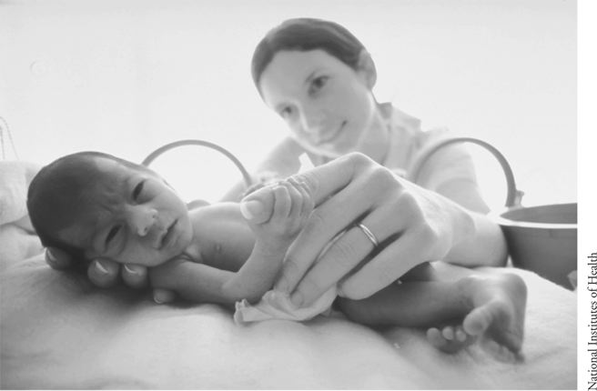
If a baby is very sick and separated from family, attachment may be delayed.
Attachment can proceed very well in spite of all these obstacles to early bonding, as long as the relationship grows and flourishes, preferably in the first year—the earlier the better. If you think back to what you know about your own birth, the chances are that you didn’t experience “bonding” immediately there in the delivery room (if you had a hospital birth). Allowing parents and babies time together right after delivery is a relatively new procedure in standard medical practice in this country. Perhaps your life might have been different if your parent(s) had been given a chance to fall in love with you at first sight immediately after your birth. Or perhaps it wouldn’t have made a difference.
Attachment, the process of creating a close and lasting relationship, may be delayed for many reasons. If the infant is very sick, parents may unconsciously protect themselves from getting attached by putting an emotional distance between themselves and the baby. Sometimes the difficulty is that, for whatever reason, the baby remains unresponsive to the caregiver’s initiations. Some infants are born with disabilities, a circumstance that cuts down on their ability to respond. Others simply don’t have the kinds of behaviors that draw adults to them. They’re not cute, or cuddly, or smiley. They don’t make eye contact. These infants, who don’t reward the adults around them, need adults who make a conscious effort to attach. Even mismatches of temperament can delay attachment as the quiet, placid parent gets used to a highly active baby, or the reverse.
If babies experience early lengthy separation, the attachment process can be disrupted. Babies in foster care may be moved around; changing caregivers can disrupt attachment. These delays or disruptions in attachment can influence future life in drastic ways if a sense of basic trust is not established. The child may put up barriers so that no one can get close. The hurt from loss is too great to chance again.
Temperament and Attachment
Temperament can affect attachment in either a negative or positive way, depending on the temperamental match between the infant and adult, whether parent or infant-care teacher. Temperament is built in and can be detected early in a child’s life. Genetically determined, temperament becomes obvious as infants show differing levels of activity, emotionality, and sociability that tend to remain the same over time. Thomas, Chess, and Birch (1963), the pioneers in temperament research, categorize babies as “easy,” “slow to warm,” and “difficult.” Their work helps today’s parents and caregivers understand how temperament affects behavior and shapes personality. J. Ronald Lally and his colleagues in the WestEd Program for Infant–Toddler Caregivers renamed the categories “fearful,” “flexible,” and “feisty,” which puts them in a more objective light. A good match between parent temperament and child temperament promotes attachment; a mismatch may hinder it. If the two aren’t a natural fit, the adult must adjust to the baby rather than expecting the reverse. This is important for you to understand—both when considering your own attachment process with the children you work with and also when working with parents. You can be the one to help a parent understand temperament if a mismatch is getting in the way of attachment between parent and child.
What would a mismatch look like? If an active and intense mother with a high energy level finds herself with a slow, calm, mild baby, she may be disappointed. She may even wonder whether something is wrong with her baby, even though the baby is perfectly fine. If this high-energy mother is not aware of what she is doing, she may overstimulate her baby. She has to learn to read the signs that the baby has had enough. You can help her do that. Some parents keep on after the baby turns away or closes his or her eyes. A serious mismatch occurs when the mother interprets this behavior as bored and continues to try to “wake the baby up and make her more lively.”
Or imagine a calm, relaxed father who loves things done on schedule and appreciates predictability in his life. He’ll find a mismatch with a highly active, intense baby who never seems able to regulate his rhythms or body needs. Some babies don’t keep any sort of routine, even eating at a different time every day. Napping is as unpredictable as appetite and never follows a schedule. If the father of such a baby doesn’t accept that his son is different from himself, he may have trouble being sensitive to the child’s needs.
Parents who have children whose temperaments don’t match their own have to adjust their expectations, accept their babies as is, and learn to understand them. They have to be flexible about how and when they respond. They have to be super-sensitive so that they can meet their baby’s needs. All that may be hard for a parent whose temperament isn’t flexible or sensitive. That may be hard for you too, but hopefully understanding more about temperament will help you.
Developmental Differences
Babies who are born with developmental differences may not have the attachment behaviors that draw adults to them. For example, neurological issues can cause babies not to be cuddly. Some stiffen when held. Some even cry out in pain when held or touched. Others who can’t control their facial muscles may not smile or look interested in the same way typically developing babies do. Or eye contact may be missing. A child with a visual impairment, for example, may not use eye contact to establish a relationship. A child with a hearing impairment may not respond to soft talking. In these cases it is important for adults to look for the attachment behaviors the children do exhibit. Adults must be constantly aware of the importance of establishing connections even if the baby’s behaviors tend to get in the way. Sometimes outside help is needed to support parents, infant-care teachers, early educators, or family child care providers when attachment isn’t occurring in spite of efforts to encourage a close connection. As you gain experience, you may be the one who provides help to the parents.
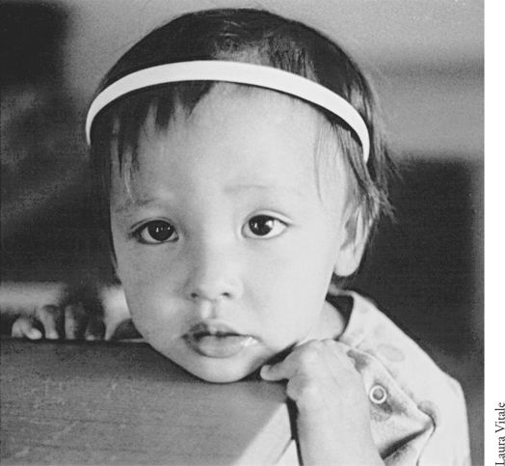
Learning to cope with feelings of loss; Children who are attached experience feelings of loss when separation occurs.
LEARNING TO COPE WITH FEELINGS OF LOSS
Babies who are attached experience feelings when separation occurs. Separation is the other side of attachment. Each human has the lifelong task of coming to grips with separations and coping with the feelings that occur as people come into and go out of one’s life. Each broken relationship, physical departure, or death brings into play all the coping skills learned earlier. The skills for dealing with separation begin to develop in infancy.
You can perhaps get in touch with the power of the feelings surrounding separation by thinking back to a time in your own life when you were apart from someone you cared about. Perhaps it was the first day of school, or a trip to the hospital, or even the first time you were left with a babysitter. It may be a less significant event—but one that sticks in your memory—like the time you took the wrong turn in the grocery store and were “lost” for a minute or two. It might be an even more significant event like the day one of your parents walked out, never to return, or the day your one of them died. All of us have experience with separation, and those experiences start earlier for some than for others.
If you can remember your feelings surrounding these experiences, you can probably get in touch with one or more of the following: panic, fear, anxiety, misgivings, apprehension, qualms, terror, horror, bewilderment, confusion, annoyance, irritation, anger, outrage, fury, wrath, frenzy, desperation, indignity, sadness, loneliness, desertion, and abandonment. The feelings come from the need for security as well as a sense of loss of control over the situation.
The memory of your pain may be intense, or it may have muted over time. Or perhaps you have a fuzziness around the feelings or even an absence of feeling. You may even dredge up a sense of depression when you get in touch with this early separation experience.
There are all kinds of separation experiences in infancy—some that help the child grow to independence, others that leave scars and long-lasting aftereffects. One common separation infants experience comes when they are put into cribs to sleep by themselves. In cultures that place a high priority on independence, this physical separation from the beginning is regarded as important. Learning to sleep alone as an infant is a skill that is valued by many in this country. It’s an important step for children coming to see themselves as separate individuals. Some parenting experts are adamant about babies sleeping alone. Some experts, including Ferber (1985), who wrote Solve Your Child’s Sleep Problems, say that babies can’t get a good night’s sleep if they have to “interact” all night with someone else.
Ironically, information on sudden infant death syndrome (SIDS, or crib death) indicates that an undisturbed night’s sleep may put infants at risk. In cultures where infants are held, jostled, and put to bed with an adult or another child, the rate of SIDS is dramatically lower than in cultures where infants sleep apart from the hustle and bustle of family life in cribs in their own rooms (Grether, Shulman, & Croen, 1990; McKenna, 1992). Of course, that doesn’t mean babies should be in bed with someone. Statistics show that placing babies on their backs to sleep makes sleeping alone in a crib safer; the “back-to-sleep” campaign is designed to lower the risk factor of sleeping alone, and it has worked!
Where babies sleep is a cultural issue. Some cultures value sleeping alone and others don’t, even if they have the space and means to do so. Some cultures aren’t as interested in their children becoming independent individuals as they are in creating a spirit of interdependence and connectedness to others. In many families both in the United States and around the world, infants and toddlers sleep with the mother or both parents until the next baby comes, then move into the bed of siblings or grandparents. Some European Americans have made an attempt to change the way they were raised by instituting what is called the “family bed” (Thevenin, 1987). More recently, trends for “co-sleeping” with the baby are finding support and even products to promote it. Sears and Sears (2001) encourage bed sharing in their book Attachment Parenting, though they also say families should decide if it’s right for them and their baby. Of course, it’s not safe for postpartum mothers who are exhausted or using sedatives to sleep with their babies.
A number of articles and books have been written about getting babies to sleep by themselves, because it isn’t as easy to accomplish as it might seem. Many babies comfort themselves while alone in the crib by developing an attachment to a particular object. This process fits right in with being part of an object-oriented culture. Most parents and caregivers are delighted when a child attaches to a favorite blanket or a stuffed animal. Experts see this particular way of self-comforting as a sign that the child has coping skills.
Learning to put oneself to sleep and stay by oneself is a step toward independence and is a valued behavior in many families. It’s a healthy sign that infants are able to handle separation.
Trent
Trent’s mother took drugs when she was pregnant. No one was aware of this problem until the day Trent was born. He arrived in the world full of the harmful substances his mother had ingested, and his first days of life were spent in withdrawal. He suffered and so did the hospital staff who tended him.
“Poor little guy!” said a nurse, as she tried to make him more comfortable.
Getting the drugs out of his system didn’t end his problems. Trent was a difficult baby from the beginning. He cried incessantly—it seemed sometimes as if he would never stop. He’d scream and scream until he finally wore himself out; he’d sleep restlessly for a period and then start again. It was hard to be around Trent.
His foster mother, a patient woman, understood how hard life was for Trent just now. Although she had other babies to care for, she spent special time with him, trying to give him the message that he was cared about—that he was loved. It wasn’t easy. When an adoptive family came along that knew Trent’s history and his problems, she was relieved because she felt he deserved a permanent home and parents—a family of his own who could give him a good deal of time and energy—the time and energy she had were stretched so thin!
Trent’s new parents were special people. They didn’t go into the adoption expecting to rescue a child and have him be forever grateful to them. They knew something about the kinds of problems that Trent had at the time and the kinds he was likely to have in the future. They were prepared to deal with these problems.
They started out right away to establish an attachment with Trent. It wasn’t easy—he wasn’t an appealing baby. When his new parents picked him up, he stiffened and shook. He didn’t cuddle like lots of babies. He seldom seemed relaxed; in fact, his movements were jerky and uncontrolled. He twitched, jiggled, and shook as he lay in his crib.
Trent didn’t like to be touched; often he screamed louder when he was touched than when he wasn’t. It was tempting to leave him alone, since picking him up seemed agonizing to him. But his parents knew that leaving him in his crib wasn’t the answer, so they did some observing and brainstorming to discover what ways they could pick him up that would cause him the least discomfort. They felt proud when they were able to discover some. It became more rewarding to pick him up.
Trent didn’t look at anyone very often. Even when his parents tried to get his attention, he tended to look away. It’s hard to develop a relationship with someone who doesn’t make eye contact, but they managed. They just kept on trying until the day came that Trent looked his mother right in the eye. What a moment that was for her—worth waiting for. That was the beginning of the development of a series of positive behaviors that made Trent easy to love. On the big day when Trent smiled for the first time, his father grinned back as if his face would split in two. “You’re going to be okay, Trent,” he said, patting his son.
Since happily-ever-after stories only occur as fairy tales, I have to tell you that Trent did continue to feel the influence of his early drug exposure into his preschool years. But with the help of his parents and their love for him, he was able to cope with the cards that life had dealt him.
VARYING ATTACHMENT PATTERNS
The classic research has been done on attachment between mothers and babies. Although attachment patterns can vary significantly from that one pattern, the early research is still worth understanding.
Bowlby and Ainsworth’s Research
John Bowlby was the first to apply to humans the idea that attachment behaviors evolved because they promote survival. He took a psychoanalytic view that attachment of infant to caregiver affects an infant’s sense of security and ability to trust.
Mary Ainsworth was a student of John Bowlby, and her research is used widely in assessing attachment of infants and toddlers. She set out to study how securely attached babies are to their mothers (Ainsworth & Bell, 1977; Ainsworth, Blehar, Waters, & Wall, 1978). She used something she called “the Strange Situation,” in which a baby is observed in an experimental room with toys designed to entice. The situation involves the mother and a stranger in a series of comings and goings. How the baby reacts to the separation, the stranger, and the reunion is used to judge the type of attachment.
From her research, Ainsworth came up with different types of attachment. If the baby is what Ainsworth called securely attached, he or she uses the mother as a base to move out from and explore the interesting toys in the room. You can see this happening in any setting where there are toys and a baby with enough mobility to get to them. Babies move away from their mothers, checking back periodically to see where they are, and crawling back to get a snuggle, hug, or a bit of comfort when needed. If the mother leaves, securely attached babies usually show some distress, but not always. They show they are delighted to see her when she returns.
Not so with insecurely attached infants. They may show what’s called avoidant attachment, resistant attachment, or disorganized/disoriented attachment. Avoidant attachment shows when babies act the same around the stranger as they do around the mother. They seem not to care when the mother leaves the room. When reunited, they are slow to greet the mother and either ignore or avoid her.
Babies who show resistant attachment stay close to the mother before she leaves and do little exploration in a strange place. They get upset when she leaves, but when she comes back they show anger and sometimes behave in a push-pull fashion—for example, alternating between clinging and pushing her away. Sometimes even picking them up fails to comfort them.
Disorganized/disoriented attachment was the product of more recent research (Main & Solomon, 1990; Solomon & George, 1999). This type of insecure attachment shows up as a pattern of confused, contradictory behaviors when reunited with the mother. Sometimes infants look frozen, dazed, and disoriented. Some rock or engage in other repetitive behaviors. Some cry after the mother has managed to get them settled down.
Ainsworth’s research provides interesting information, but be careful about judging attachments in families you work with. You’re not a researcher, and you can’t understand everything about a family based on what you see when they leave their children. One criticism of Ainsworth’s way of judging attachment is the unnatural setting. Do babies and mothers behave the same in a laboratory as they do at home or somewhere else?
Another criticism of the Strange Situation as a way of assessing attachment is that it is based on a particular model of mother-child attachment. There are a lot of variations on that model. What if the baby has been in child care and is used to multiple caregivers? Is he really showing insecure attachment if he avoids the mother when she returns, or is he accustomed to having an interesting environment and being separated from his mother? Or what if the baby comes from a large family in which the mother isn’t the only caregiver? What if the mother isn’t the person the baby is most attached to? What if the baby has two mothers? Or two fathers?
Questions About Classic Attachment Research
Ainsworth and other researchers focused on attachment as it relates to the insular or nuclear family. Today we know better. We can see with our own eyes that, even in the nuclear or insular family, caregiving may be shared between mother and father or between one parent and another relative or child care provider. Under these circumstances, attachment is not just between mother and baby, although often the mother remains the primary attachment.
As mentioned earlier, much of the focus on attachment has been related to the insular or nuclear family with mother, father, and child. This, of course, isn’t the only kind of family. Another type of family is the single-parent family. Sometimes the parent(s) and baby are not a unit by themselves but are part of a larger extended family. Stack (1991) describes kinship networks as clusters of people who are related through children, marriage, and friendship who come together to provide domestic functions. This domestic network may spread over several households, and changes in individual household composition do not significantly affect cooperative arrangements. The single-parent family that finds itself in this type of network may be thought of as “embedded” rather than alone.
A woman once told me a story about how she had changed her perspective on her family. This person was a single parent with two children, who lived with her parents in their house. She thought of her situation as two families living in one house, until she decided to have a family portrait taken. She included all five family members, deciding for herself that this was one family, rather than two. This story of her family portrait started me thinking about my own family situation as I grew up. My mother, my sister, and I lived most of my childhood in the house of my grandparents. We never had a family portrait taken. We didn’t see ourselves as a unit; rather, we were two families—an intact one (my grandparents) and a “broken” one (my mother and her two children). Nowadays, of course, we would call ourselves a single-parent family rather than a broken one, but many would still see us as deprived without a father in the household, rather than enriched because of grandparents and the uncles who lived there for periods during my growing up. I now prefer to think of myself as growing up embedded in my extended family.
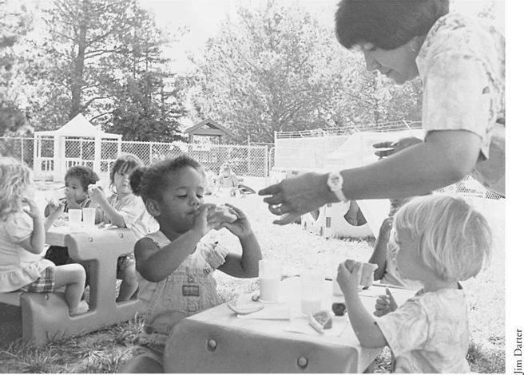
Children can acquire secondary attachments in child care in addition to those at home.
The concept of an embedded family is a more positive and realistic one. In an embedded family the attachment might be quite different because of shared caregiving. Certainly that was my experience. My attachment to my grandmothers was as strong as my attachment to my mother. Although we may think of the mother-child dyad as the way “it should be,” that’s not necessarily so. The child can become attached to several caregivers or to a group rather than to just one or two individuals. When you are used to looking at attachment as an exclusive relationship, you may be concerned about the infant who is attached to multiple caregivers (Zimmerman & McDonald, 1995). However, cultures all over the world raise their children this way. Shared care has advantages over one or even two parents carrying total responsibility for a child’s well-being. What a burden that much responsibility can be, especially for a new parent who may have had little previous experience with babies!
Some child care programs function as an extended family, a kinship network, or a family-support system, rather than as just a place to leave children during the day. These programs are able to provide families with the kind of connections they would find in embedded families if they had them. One such family support system is the Parent Services Project, which a visionary child care director, Ethel Seiderman, started in California, and which has now spread nationwide in the United States. The purpose of this project is to help programs recognize that the well-being and sense of significance of parents are of central importance to the child’s development. Furthermore, support is important to all families, and social-support networks reduce isolation and promote the well-being of the child, the family, and the community.
JUDGING ATTACHMENT IN A CROSS-CULTURAL SITUATION
When a mother doesn’t seem sensitive to the baby’s emotional signals, seldom speaks to the baby, and/or never holds the baby in a face-to-face position so adult and baby can make eye contact, it is not clear whether these are functional or dysfunctional behaviors. Do they fit customs and expectations and make sense if viewed in cultural context? Or are they left over from a time when survival was the main issue and many babies died before their first birthday? Or do they have another explanation? For example, in a situation in which the baby is never called by the given name, you may not immediately understand what is going on, unless you are of the same culture and social class as the family you’re observing. If you don’t thoroughly understand the culture and perhaps even the individual family, you can’t make judgments about the way people are raising their children and whether they have a healthy attachment.
Language is another area in which an outsider may misjudge what is happening. European American middle-class families are very vocal, and all this vocalization is part of the attachment process. Watch most middle-class European American parents and you’ll see that they talk face-to-face with their babies—chattering away as if the baby understands. They even wait for a response, creating a turn-taking situation that imitates real conversations in which both participants talk. Research (done by European Americans on European Americans for European Americans) shows the value of this kind of behavior, not only for attachment but also for future development. For example, this early emphasis on verbalization makes a difference later in school performance; children with good verbal skills do better academically.
In contrast, some families rarely speak to their infants. What may not be clear to the outsider is how much the family is using nonverbal communication that the observer isn’t aware of. Because a family doesn’t behave the same as a European American middle-class family toward babies doesn’t necessarily mean that there is an attachment problem—it may be more a matter of cultural difference.
CHILD CARE AND ATTACHMENT
For many who come from the tradition of mother-child attachment as an exclusive relationship, a crucial question is: What does child care do to attachment? This section focuses on child care rather than the larger picture of early care and education because the concern relates to long hours out of the home. Preschool, kindergarten, and primary school don’t cause people to worry about attachment for several reasons. The time factor is one. When children leave home for preschool they aren’t gone for as many hours as they may be when in full-day child care. Age is another reason. Children are older when they leave home for preschool, and presumably attachment to family has already occurred. The big worry is when an infant who is still in the beginning stages of attachment spends most of his or her waking hours away from home and family.
From the days of the classic research on orphanages, the term maternal deprivation rings in the ears and sends chills down the spine. Horror stories of old-time orphanages come to mind—babies left to themselves in rows of cribs along sterile walls. The picture is heartbreaking. Those babies had no attachment, few interactions, little power to influence anyone in their lives, a feeling that no one cared about them, and a great lack of any kind of sensory stimulation. No wonder many died and the rest were left impaired. More recent orphanage pictures come to us from Romania and China. Not pretty pictures!
Resistance to creating child care for babies has been strong, but when Clinton signed the welfare reform bill and sent mothers of babies out of the home, that resistance melted. Some still worry about group care for babies—and well they should. It takes special knowledge and expertise to do a good job with babies. Now we know you can’t just line babies up in cribs, change and feed them on schedule, and expect them to be okay while their family members are working.
Luckily we have better models than those old-time orphanages. From Budapest in Hungary comes a different picture. The children thrive in the Pikler Institute, which was mentioned earlier in this chapter. There attachment has been carefully thought through and fits into a comprehensive approach that has been studied by the World Health Organization. According to their results, children who spent their first three years in this residential care nursery end up as adults who show none of the signs of impairment that children from deprived orphanages show. A key factor is the approach taken to attachment described in a book called Loczy: An Unusual Approach to Mothering (David & Appell, 2001).
Effects of Child Care on Attachment
Child care is not an orphanage; the children have families who are raising them. Child care is supplemental to these families, not a replacement for them. A way to look at attachment in out-of-home-child care is this. Children in child care have not just one person who cares about them—a parent—but often two or more. Children usually arrive in child care already firmly attached to their own family and may well acquire a secondary attachment or two in child care.
A look to Israel reassures us that parents and children can remain attached even if the parents never live with their children or are never responsible for their day-today care. In some of the kibbutzim in Israel, where communal living was a norm and a value, children were raised from infancy separate from their parents. They visited their parents, but they didn’t live with them. Full-time caregivers/teachers, rather than the parents, were in charge of child rearing and education.
There was no lack of attachment between parents and children in the kibbutzim. Attachment looked different because children split their attachment between parents and peer group. However, each child was well aware of his or her identity as a member of his or her own family—and each felt a sense of belonging.
Another question to ask when looking at the effects of child care on attachment to family is: What is the situation of the child’s family? Obviously if a family is overwhelmed by stress and the members are not functioning well, and a baby is born into the family at this point, some protective factors may be crucial. The early care and education program can provide these factors. In some situations, as when an overburdened single parent is able to get the support and referral to services needed, the child care program can literally be a lifesaver.
Such programs exist. Some child care and early education programs in the United States today not only give services to children but also give families the support they need to get on their feet so they, themselves, can provide for their children’s needs. These kinds of programs are cost-effective because they deal with attachment and other needs at the beginning rather than trying to fix problems that arise later, which is much more expensive (Pawl, 1995; Raikes, 1996). We could use many more of these kinds of programs! Prevention is a key word when looking at early deprivation and attachment problems.
Unfortunately, these kinds of comprehensive programs are too few in number. If the baby in the above example is placed in a child care program in which he never gets to know any of his caregivers and his mother gets little or no support, it’s a different story. Attachment may be delayed because caregivers come and go too fast. Not one of the adults gets to know him well enough to read his signals, understand his uniqueness, become fond of him. Child care may save his life yet still not provide for his attachment and trust needs. Because of underfunding, that’s the tragedy of the state of many child care programs in the United States today. The turnover rate of caregivers and teachers in underfunded programs is shocking.
You can’t know exactly how child care affects attachment without considering countless variables that have to do with the quality of the care and the way the family works. One important aspect of quality care is the partnership between the parents and the program. When child care staff and providers develop a collaborative relationship with the parents that includes more than just parent education and involvement, everybody stands to gain—including the child!
Some parents don’t have much choice about using child care for their babies and won’t until parental leave becomes a societal policy. It may reassure these parents to know that most studies have shown that babies become attached to their own parents even when child care is begun quite early.
How Caregiver and Parent Roles Differ
Good infant-care teachers have many of the qualities of good parents, and those qualities promote attachment (Katz, 1980). One vital quality is sensitivity. When the infant-care teacher learns to read each infant’s signals, he or she can respond appropriately and in a timely fashion, that is, if the staff-child ratio is good. Infants learn that they can give messages. They can influence the people in their world. They have personal power. They become attached. The attachment grows out of the sensitivity and the ability of the infant-care teacher to communicate and also promotes further communication. Infants becomes better at sending signals when someone is trying to read theirs. The infant-care teacher gets better and better at reading signals as he or she grows to know the baby as an individual. A synchronous relationship results.
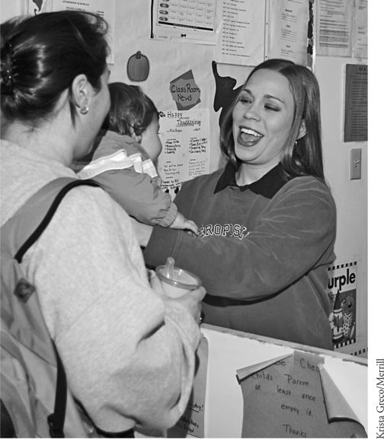
The child’s attachment to the teacher should always be secondary to that of the family—close enough for security, but not too close.
Good infant-care teachers and good parents have many similar behaviors and goals, but they also have some differences, which Lilian Katz, professor at the University of Illinois and a longtime leader in the field of early childhood education, wrote about. Katz (1980) says that the infant-care teacher’s attachment is necessarily short-term, and it’s important for him or her to remember that fact. This child care arrangement isn’t forever; the infant-care teacher has little control over the future. It’s the parents’ job to have a vision for the child’s future, just as they have the knowledge of the past. It’s the parents—the family—who connect the child in time, giving a sense of continuity. The child has a life beyond child care; that’s a fact that the infant-care teacher must keep in mind.
Parents and infant-care teachers differ in the degree of closeness that’s appropriate. The goal of parental attachment is to establish optimum closeness with the child; the infant care teacher’s goal is optimum distance. The child benefits from attachment to both, but it’s a different kind of attachment. The infant-care teacher must put limits on the degree of attachment; after all, the family may move out of town tomorrow. In addition, infant-care teachers usually have other children to consider; they can’t allow themselves to get completely wrapped up in just one to the neglect of the others. Strategy Box 2.1 includes a summary of ideas for early educators when keeping their role separate from the roles of parents.
Strategy Box 2.1
Working with Families Around Attachment Issues
♦ Recognize that the well-being and sense of significance of parents are of central importance to the child’s development.
♦ Work to build a trusting relationship with each family.
♦ See yourself as a support for families instead of merely being there for their children.
♦ If policies are in place in an infant center that allow attachment between infant-care teachers and a small number of children, do what you can to promote that attachment. If there are no such policies, discuss with the people in power the need for them.
♦ Keep in mind that your attachment is secondary to that of the parents. Examine the degree of closeness with each child with a professional eye. Be close enough to help the child feel secure, but not so close that the child turns from family to you.
♦ Avoid competition with family for the child’s affection.
Fairness is another category in which parents and infant-care teachers differ. Parents can be advocates for their own children. They don’t have to be fair and consider all the children in the program. It’s appropriate for parents to focus on their own children. Infant-care teachers can’t afford to favor one child over another, but that doesn’t mean that they must treat all the children in their care alike. Similar treatment in the face of differing needs doesn’t create fairness.
Attachment in Full-Inclusion Programs
Full-inclusion programs are those where children with developmental differences, disabilities, and particular challenges are placed in child care with their typically developing peers rather than being separated into special programs. Every adult involved in such programs must aim to help all children feel they belong. That means that the children with exceptional needs must be integrated into the group. Unless the adults in the program have the time and skill to facilitate this integration, some children may feel left out. Although this attention to integration is slightly different from the kind of attachment this chapter has focused on so far, it brings up the issue of attachment not just to an adult or two, but also to the group.
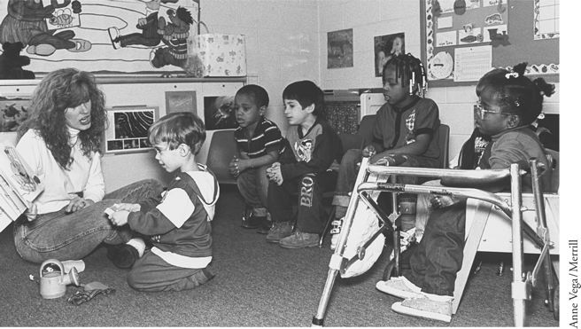
The goal is to help every child feel he or she belongs.
The work of Lev Vygotsky has implications for integration. Vygotsky worked at the Institute of Psychology in Moscow where he created what’s called sociocultural theory, which emphasizes social interaction as an influence on development and learning. His zone of proximal development, or moving children forward from where they are to where they can be, involves peer interaction (Berk, 2001).
LOOKING BACK AND LOOKING FORWARD
Trust and attachment are lifelong issues. When conditions are right, parents and babies get “hooked” on each other right from the beginning. The relationship that results serves both well. It not only ensures the baby the nurturing and protecting he or she needs at the beginning, but also sets the stage for later relationships. Being attached feels good. It offers security. The job of the early care and education professional is to help support attachment to the family as well as encourage a secondary attachment in the center or family child care home.
Attachment provides the security that the baby needs to move out from the parent and care provider to become a fully functioning individual. That subject is the focus of the next chapter.
FOR DISCUSSION
1. Have you been aware of attachment occurring? Describe the kinds of interactions that encourage attachment that were part of this experience. Was synchrony involved? How did the attachment serve the people who were becoming attached? Tell about that experience.
2. What are your experiences with obstacles to the bonding or attachment process? Did the people involved get over or around these obstacles? How?
3. Discuss separation anxiety. What behaviors indicate the child is trying to keep the attached person from leaving? What emotions might a child display? How can an adult help the child to separate from the person he or she is attached to?
4. Have you had any experience with how child care might affect attachment? What are your ideas or thoughts about this subject?
5. What are your ideas, thoughts, or feelings about working with families around issues of attachment? What experience do you have in supporting parents’ attachment to their infant?
WEB SITES
Attachment Disorder Site
http://www.attachmentdisorder.net/
Many resources and additional links here pertain to attachment, attachment disorder, and related issues.
I Am Your Child
http://www.iamyourchild.org/
This site includes the connection between warm interactions leading to attachment and brain development.
Institute for Attachment and Child Development
http://www.instituteforattachment.org/
This Web site identifies issues that transform the lives of families and children with attachment, behavioral, and emotional disorders and promoting healthy family relationships.
Pikler Institute
http://www.pikler.org/
and
International Pikler Association
http://www.aipl.org
Both Web sites give information on the Pikler approach used at the Pikler Institute, a residential nursery in Budapest, Hungary, an approach which focuses heavily on attachment.
Program for Infant/Toddler Caregivers (PITC)
http://www.pitc.org/
The Program for Infant/Toddler Caregivers supports and promotes quality care for infants and toddlers through resources, information, and training. The site includes information on brain research and implications for infant development.
Resources for Infant Educarers
http://www.rie.org/
Resources for Infant Educarers™ is a nonprofit organization that uses the teachings of Magda Gerber to promote a unique philosophy and methodology in working with infants in ways that respect them as individuals.
Society for Research in Child Development (SRCD)
http://www.srcd.org/psarchive.html
The Society for Research in Child Development Web site contains information summary of many research articles on child development, including several on attachment.
Zero to Three
http://www.zerotothree.org/
Zero to Three: National Center for Infants, Toddlers, and Families is designed for parents and professionals. A leading resource on the first three years of life, its mission is to strengthen and support families, practitioners, and communities to promote the healthy development of babies and toddlers.
FURTHER READING
Berlin, L. J., Ziv, Y., Amaya-Jackson, L., & Greenberg, M. T. (Eds). (2005). Enhancing early attachments. New York: Guilford..
Barnard, K., & Brazelton, T. B. (Eds.). (1990). Touch: The foundation of experience. New York: Bantam.
Bernhard, J. K., & Gonzalez-Mena, J. (2000). The cultural context of infant-toddler care. In D. Cryer & T. Harms (Eds.), Research to practice in infant-toddler care (pp. 237–267). Baltimore: Brookes.
Bhavnagri, N., & Gonzalez-Mena, J. (1997, Fall). The cultural context of caregiving. Childhood Education 74(1), 2–8.
Chang, H. N. L., Muckelroy, A., & Pulido-Tobiassen, D. (1996). Looking in, looking out: Redefining child and early education in a diverse society. San Francisco: California Tomorrow.
David, M., & Appell, G. (2001 [1973, 1996]). Loczy: An unusual approach to mothering. Translated from Loczy ou le maternage insolite, by Jean Marie Clark; revised translation by Judit Falk. Budapest: Association Pikler-Loczy for Young Children.
Derman-Sparks, L. (1995). The process of culturally sensitive care. In P. Mangione (Ed.), Infant/toddler caregiving: A guide to culturally sensitive care (pp. 40–73). Sacramento: Far West Laboratory and California Department of Education.
Egeland, B., & Farrell Erickson, M. (1999, October–November). Findings from the parent-child project and implications for early intervention. Zero to Three 20(2), 3–9.
Gerhardt, S. (2004). Why love matters: how affection shapes a baby’s brain. London: Routledge.
Gillespie, L. G. (2006, September). Rocking and rolling: Supporting infants, toddlers and their families: Cultivating good relationships with families can make hard times easier! Young Children 61(5), 53–55.
Gonzalez-Mena, J. (2004, September). What can an orphanage teach us? Lessons from Budapest. Young Children 58(5), 26–30.
Gonzalez-Mena, J. (2006) Caregiving and literacy. In J. Knapp-Philo and S. Rosenkoetter (Eds.) Learning to Read the World: Language and Literacy in the First Three Years. Washington DC: Zero to Three.
Gonzalez-Mena, J. (2007). What to do with a fussy baby: A problem-solving approach. Young Children 62(5), 20–25.
Gonzalez-Mena, J., & Bernhard, J. K. (1998, Summer). Out-of-home care of infants and toddlers: A call for cultural and linguistic continuity. Interaction 12(2), 14–15.
Honig, A. S. (2002). Secure relationships: Nurturing infant/toddler attachment in early care settings. Washington, DC: National Association for the Education of Young Children.
Schneider, B. H., Atkinson, L., & Tardif, C. (2001). Child-parent attachment and children’s peer relations: A quantitative review. Developmental Psychology 37, 86–100.
Stern, D. N. (1990). Diary of a baby. New York: Basic Books.
Wittmer, D. S., & Petersen, S. H. (2006). Infant and toddler development and responsive program planning: A relationship-based approach. Upper Saddle River, NJ: Merrill/Prentice Hall
(Child, Family, and Community: Family-Centered Early Care and Education, 5th Edition. Pearson Learning Solutions p. 24).
<vbk:0558582508#outline(5)>

