Estimators may use a wide variety of techniques to perform the project cost effort. It is customary, in fact, for the estimator to use at least two techniques and then “triangulate” the two (i.e. discuss the reasons why the two estimates have differences). Often, the “true” estimate is the average of the results of the various estimation methods used.

One of the more popular estimation methodologies is COCOMO (Cost Construction Model II), devised by Dr. Barry Boehm in 1981 (see http://sunset.usc.edu/Research_Group/barry.html), which is both a formula and a software tool (http://sunset.usc.edu/research/COCOMOII/). Figure 3 shows its application to cost estimation in project planning.

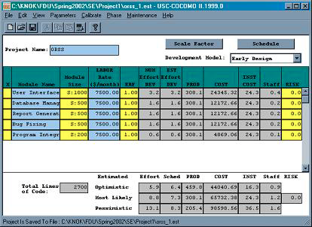

Figure 3. Using COCOMO to estimate a project’s cost.

The “true” cost of a project must also include software and hardware required, time expended by outside personnel such as trainers, end-users, managers as well as administrative overhead.

