In the hydraulic system shown in Figure 15-28 the piston on the left has a diameter of 4.9 cm and a mass of 1.7 kg. The piston on the right has a diameter of 12 cm and a mass of 2.9 kg. If the density of the fluid is 750 kg/m³, what is the height difference h between the two pistons?
m
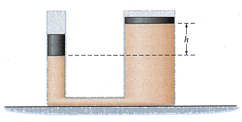
Figure 15-28

