Larry Edison is the director of the Computer Center for Buckly College. He now needs to schedule the staffing of the center. It is open from 8 am until midnight. Larry has monitored the usage of the center at various times of the day and determined that the following number of computer consultants are required.
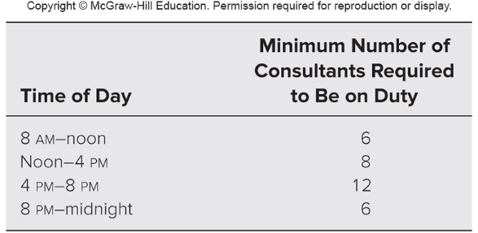
Two types of computer consultants can be hired: full-time and part-time. The full-time consultants work for eight consecutive hours in any of the following shifts: morning (8 am –4 pm), afternoon (noon–8 pm), and evening (4 pm –midnight). Full-time consultants are paid $14 per hour.
Part-time consultants can be hired to work any of the four shifts listed in the table. Part-time consultants are paid $12 per hour.
An additional requirement is that during every time period, there must be at least two full-time consultants on duty for every part-time consultant on duty.
Larry would like to determine how many full-time and part-time consultants should work each shift to meet the above requirements at the minimum possible cost.

  - Which category of linear programming problem does this problem fit? Why?

  - Formulate and solve a linear programming model for this problem on a spreadsheet.

  - Summarize the model in algebraic form.

