Submit Part 1 (handout) in a separate document. Submit Parts 2 and 3 together in one document.

Part 1 – Understanding Regression Terminology

Create a handout for students in an introductory statistics course which summarizes the following regression terms (in your own words):
  - R² versus Adjusted R²
  - Beta
  - Regression Coefficient
  - Hierarchical Regression
  - Multi-collinearity
  - Curvilinear
  - Homoscedasticity
  - Outlier
  - Ordinary least squares
  - Residual

Part 2 – Simple Linear Regression

An organization wants to use interview scores to predict performance in an employee development program. Review the regression results in Figure 5 below:

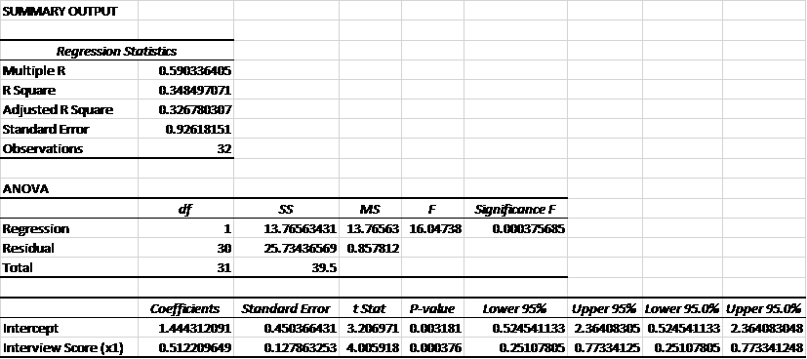
Figure 5. Summary output from a simple linear regression analysis produced by Excel. The results are organized in three tables - 1) regression statistics including the R squared, standard error, and number of observations, 2) ANOVA F-tests for the regression model and residuals, 3) and significance tests for the coefficients.
  - Are the results significant? Explain your response.
  - Use the summary output to find the least square regression line: y = ax + b
  - Jeff Jones has an interview score of 3.4. Estimate the value of y (performance) when x = 3.4.
Part 3 – Multiple Regression

The organization wants to use a combination of interview scores (x₁), scores from a role playing exercise (x₂), and personality test scores (x₃) to predict performance (y) in the employee development program. An I/O psychologist collected data on the 32 employees who have already participated in the program. The employee data are presented in Week 6 Data file. Open the file to the Employee Summary tab.
  - Run a multiple regression analysis in Excel
  - Copy the summary output (Regression Statistics Table, ANOVA Table, and Coefficient Table) into a Word document.
  - Are the results significant? Explain your response.
  - Should all predictors be included in the least squares regression line? Should any predictors be excluded? Why or why not?
  - Use the summary output to find the least square regression line: y = ax₁ + ax₂ + ax₃ +b
  - Estimate the y (performance) for the following two candidates (show your work):
 | Interview Score | Role Play Score | Personality Test Score
Laura | 5 | 4 | 45
Gary | 4 | 5 | 40
7. Based on these results which candidate would you select into the employee development program?

Length: 1 page handout; and a 1-2 page results and summary

