Height of a Zero Gravity Parabolic Flight
Math 1010 Intermediate Algebra Project

Background Information
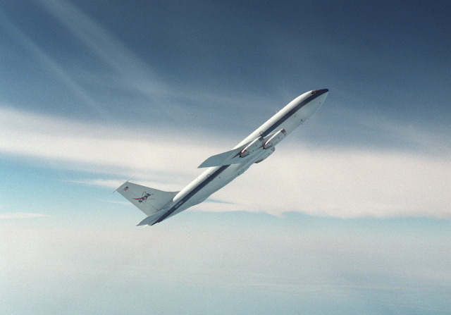
Have you ever wondered what it might feel like to float weightless in space? One way to try it out is to fly on a special aircraft that astronauts use to train for their trips to space. Both NASA and the Russian Space Agency have been flying these for years. The way this is accomplished is to fly to a high altitude, drop down to gain speed, and then start a large parabolic path up in the sky. For a time ranging from 10 to 20 seconds, along the top part of the parabolic flight, an environment simulating zero gravity is created within the plane. This effect can cause some nausea in the participants, giving rise to the name “Vomit Comet”, the plane used by NASA for zero-G parabolic training flights. Currently there is a private company that will sell you a zero-G ride, though it is a bit expensive.
The Problem
This lab will have you look at the parabolic path to try to determine the maximum altitude the plane reaches. First, you will work with data given about the parabola to come up with a quadratic model for the flight. Then you will work to find the maximum value of the model. Now for the data:
Time (t) in seconds | Height (h) in feet
2 | 23645
20 | 32015
40 | 33715

To find the quadratic model, you will be plugging the data into the model

$h=at^{2}+bt+c$.

The data points given are just like x and y values, where the x value is the time t in seconds and the y value is the altitude h in feet. Plug these into the model and you will get equations with a, b and c.

Modeling the Problem

Part 1: Write your 3 by 3 system of equations for a, b, and c.

Part 2: Solve this system. Make sure to show your work.

Part 3: Using your solutions to the system from part 2 to form your quadratic model of the data.

Part 4: Find the maximum value of the quadratic function. Make sure to show your work.

Part 5: Plot the parabola. Do this on an online graphing technology and copy and paste the results below. Label the given data plus the maximum point. A good way to start labeling your axes is to have the lower left point be (0, 20000)

