- Carbon Dioxide Emissions 2012
Below is data from the Earth Policy Institute showing the top 10 countries’ fossil-fuel carbon dioxide (CO₂) emissions during 2012. The bar chart at the right comes from a 2012 CO2 report published by the PBL Netherlands Environmental Assessment Agency.
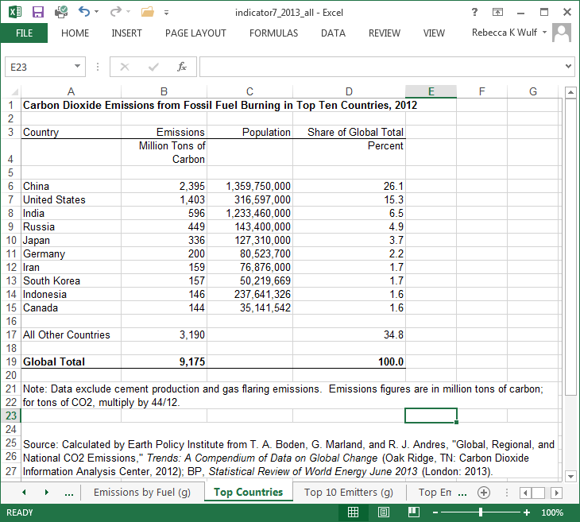
Source: http://edgar.jrc.ec.europa.eu/CO2REPORT2012.pdf
Open the CO2 data spreadsheet in Excel. You may use Excel to do your calculations.
- Determine the average CO₂ emissions of the top 10 countries.
- Calculate the per capita emissions for each country.
- Write a paragraph explaining whether total emissions or per-capita emissions is a better gauge when comparing the CO₂ emissions of various countries.
- Find the mean and the median per-capita emissions among the top 10 nations.
- Write a short paragraph explaining which measurement (mean or median) would be used by an environmentalist to support the position that CO₂ emissions per capita are too high?

- For each of the graphics below:
A. Determine whether the following distributions are skewed right, skewed left or symmetrical. B. Based on your answer to part A., would the mean be above or below the median in each case.
C. Write a sentence for each graphic about the information shown on the graphic.
Graphic 1
Source: http://rwer.wordpress.com/2011/02/25/25-graphics-showing-upward-redistribution-of-income-and-wealth-in-usa-since-1979/
Graphic 2
Source: http://www.statista.com/statistics/192700/age-distribution-of-us-users-on-linkedin/
Graphic 3
Source: http://www.calculatedriskblog.com/2009/08/us-population-distribution-by-age-1950.html
- Buying the best. Sara is researching phones and decides to use a weighted average score to determine the ‘best’. She uses the following weights: 50% battery life, 30% cost, 20% camera. She finds the following ratings out of 10 for each category on the internet. Determine the weighted average score for each phone using Sara’s strategy. Which phone will she choose?
 | Battery | Cost | Camera
I-Phone | 9 | 7 | 8
Samsung | 9 | 7 | 7
Motorola | 8 | 9 | 8

- Suppose you wanted to use Excel to calculate the scores for the phones in the problem above.
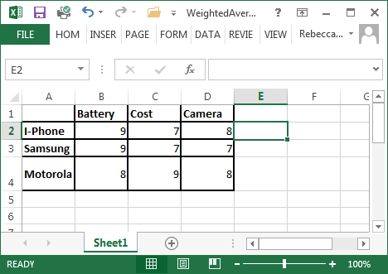
What would you need to type in cell E2 to calculate the weighted average for the I-phone?

