- Great Northwoods Outfitters is a retail phone-catalog company that specializes in outdoor clothing and equipment. A phone station at the company will be staffed with either full-time operators or temporary operators 8 hours per day. Full-time operators, because of their experience and training, process more orders and make fewer mistakes than temporary operators. However, temporary operators are cheaper because they receive a lower wage rate and are not paid benefits. A full-time operator can process about 360 orders per week, whereas a temporary operator can process about 270 orders per week. A full-time operator averages 1.1 defective orders per week, and a part-time operator incurs about 2.7 defective orders per week. The company wants to limit defective orders to 200 per week. The cost of staffing a station with full-time operators is $610 per week, and the cost of a station with part-time operators is $450 per week. Using historical data and forecasting techniques, the company has developed estimates of phone orders for an 8-week period, as follows:
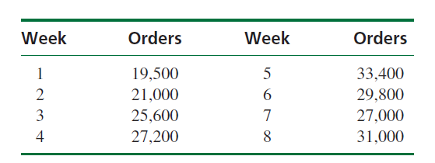
The company does not want to hire or dismiss full-time employees after the first week (i.e., the company wants a constant group of full-time operators over the 8-week period). The company wants to determine how many full-time operators it needs and how many temporary operators to hire each week to meet weekly demand while minimizing labor costs.
a. Formulate a linear programming model for this problem
b. Solve this model by using the computer.
c. Great Northwoods Outfitters is going to alter its staffing policy. Instead of hiring a constant group of full-time operators for the entire 8-week planning period, it has decided to hire and add full-time operators as the 8-week period progresses, although once it hires full-time operators, it will not dismiss them. Reformulate the linear programming model to reflect this altered policy and solve to determine the cost savings

- A steel company is producing steel for a new contract. The contract specifies the information in the following table for the steel.
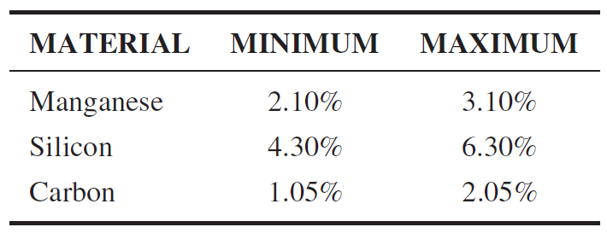
The steel company mixes batches of eight different available materials to produce each ton of steel according to the specification. The table shows details of these materials.
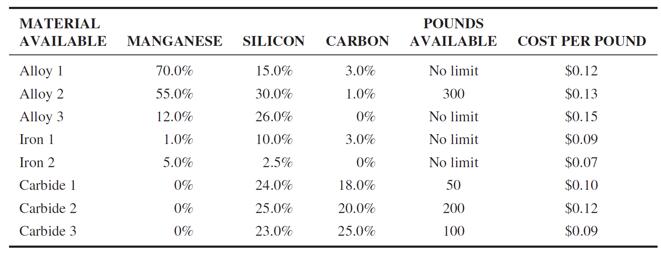
Formulate and solve the LP model that will indicate how much of each of the eight materials should be blended into a 1-ton load of steel so that the company can meet the specifications under the contract while minimizing costs.

- Clint Hanks has decided to try a new diet that promises enhanced muscle tone if the daily intake of five essential nutrients is tightly controlled. After extensive research, Clint has determined that the recommended daily requirements of these nutrients for a person of his age, height, weight, and activity level are as follows: between 69 grams and 100 grams of protein, at least 700 milligrams of phosphorus, at least 420 milligrams of magnesium, between 1,000 milligrams and 1,750 milligrams of calcium, and at least 8 milligrams of iron. Given his limited finances, Clint has identified seven inexpensive food items that he can use to meet these requirements. The cost per serving for each food item and its contribution to each of the five nutrients are given in table
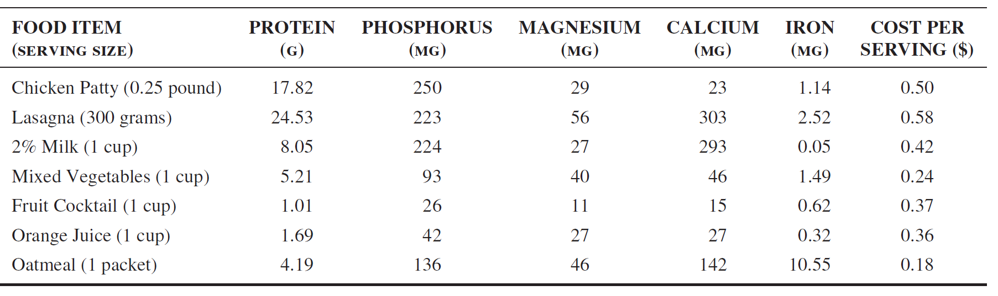
(a)Use LP to identify the lowest cost combination of food items that Clint should use for his diet.
(b) Would you characterize your solution in (a) as a well-balanced diet? Explain your answer.

