Chicken eggs are sold according to their size. The chart shows how eggs are classified by their size.
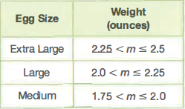
The eggs produced at Jen’s Hen Farm and Rick’s chick Farm are normally distributed. The eggs produced at Jen’s Hen Farm have a mean weight of 2.11 ounces and a standard deviation of 0.08 ounce. The eggs produced at Rick’s chick Farm have a mean weight of 2.15 ounce and a standard deviation of 0.07 ounce. Each farm produces a total of 100,000 eggs per month.
22. If Jen and Rick each randomly select an egg from their farm, who Is more likely to select an egg classified as large?
23. If Jen and Rick each randomly select an egg from their farm, who Is more likely to select an egg classified as medium?
24. Jen and Rick sell their extra large eggs for 90 cents per dozen. Estimate the amount of money they each make per month from the sale of extra large eggs.

