In this worksheet, you will calculate the amount of carbon dioxide, or “carbon footprint,” emitted by just one stage of a plastic water bottle's life cycle: transportation. You will also perform some other calculations related to bottled water consumption in the United States. Use the answers you calculate to inform your report’s discussion of the environmental impact of using bottled water.

For this worksheet, we will consider the best-selling product of the Warsaw Springs Bottling Company of Warsaw Springs, Maine: the ½-liter (.5 L) spring water bottle.

Perform the following calculations to identify roughly how much carbon dioxide is emitted from transporting the product. For each problem below:
- Include the equations or formulas you used.
- Explain, in words or with mathematical steps, how you arrived at your answers. You do not have to submit sketches, but you may find that drawing parts of the problem on scratch paper can help you understand the problem.
- Include all relevant units (such as miles or cubic inches) in your final answers.
- Round answers to one decimal place unless indicated otherwise.
***
- Warsaw Springs bottled water is shipped away from the plant by truck, which will travel an average speed of 65 miles per hour.
  - How many hours will it take the truck to drive from the bottling plant to the BigMart store located 121 miles away in Manchester, New Hampshire?

  - Convert your answer above to minutes. Round to the whole minute.

- The carbon footprint from transporting the water depends in part on the number of products that can be transported at one time. The water bottles are shipped upright in shrink-wrapped cases, 24 to a case.
Case Dimensions |  | 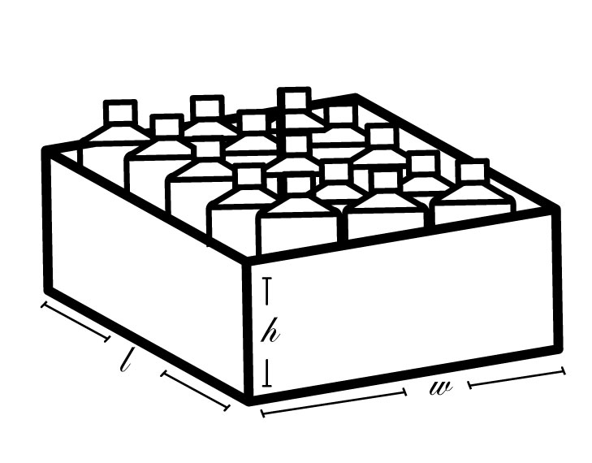  Figure 1: Case of water.  Note: Diagram not to scale.
length | 15.1 in.
width | 8.3 in.
height | 10.2 in.

Using the numbers in the table above, what is the area of the base of one case? What is its perimeter? Its volume?
Note: Area units can be expressed as square inches (in²); volume units can be expressed as cubic inches (in³).

- The cases are then placed upright in a truck, with as many as will fit in the truck lined up and stacked. The diagram below shows one case loaded in the truck. Every case is loaded in the same orientation as the one in the diagram.

Trailer Interior Dimensions |  | 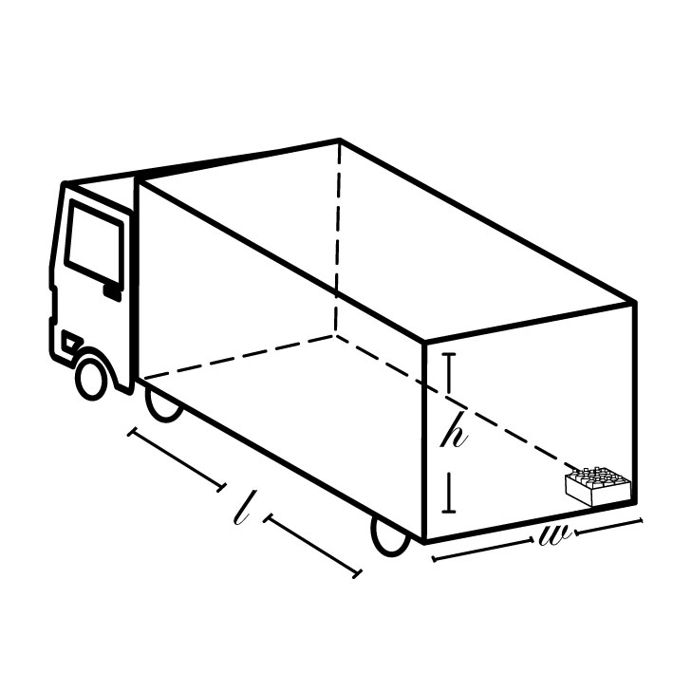  Figure 2: Tractor-trailer with trailer section. Note that the length of the case is aligned with the length of the truck.
Length | 47 ft.
Width | 8.5 ft.
Height | 9 ft.

  - What is the length of the longest case array that could fit on the truck with the long side of each case set along the length of the truck, as in the diagram? The width? The height? Provide your answer in feet, rounded to one decimal place.

  - What is the volume of the case array loaded into the truck?

  - How many whole cases can be loaded in the truck in this manner? How many bottles?

  - How much leftover space is there in the truck?
Hint: Consider the measurements of cases, not bottle contents.

- Assuming that the full truck emits 184.6 kilograms of carbon dioxide per 100 miles, calculate how much carbon dioxide the vehicle emits on this trip.

- Based on your answers to the questions above, how many kilograms of carbon dioxide are emitted per bottle of water on this trip? What is that in pounds? Show your answers to six decimal places.
Note: 1 pound = 0.45 kilogram

- Assume that a total of 9.1 billion gallons of bottled water was consumed in the United States last year. (The real number is probably higher.) If all of this water was in the form of ½-liter bottles that traveled the same distance as the Warsaw Springs bottles in our example, how much carbon dioxide, in pounds, was emitted into the atmosphere during transportation of the final product?
Note: 1 billion = 1,000,000,000
1 gallon = 3.79 liters

- Some water travels much farther than our Warsaw Springs example. The bottles that contain FIJI® water are produced in China before being shipped to Fiji to be filled with water. FIJI water that will be sold in the United States must then be shipped to the United States as well. It is about 8,700 kilometers from China to Fiji and another 8,000 kilometers from Fiji to San Francisco. How far, in miles, do FIJI water bottles travel before they arrive in the United States?
Note: 1 mile = 1.6 kilometers

Assume that the United States consumes 2.6 billion cases of bottled water per year. Assume that those cases are all Warsaw Springs cases (see problem 2 for case information).

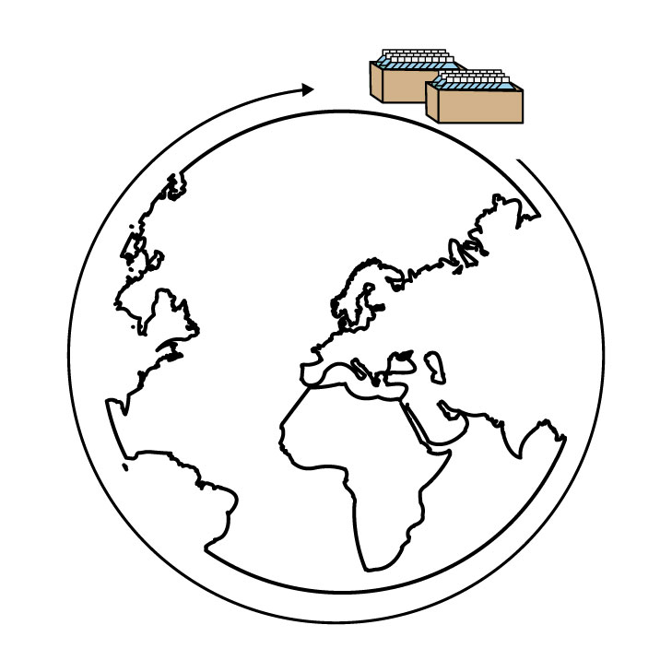

Figure 3: A line of water bottle cases circles the Earth.

  - Imagine Warsaw Springs cases lined up end-to-end. Let that line extend all the way around the earth. The circumference of the Earth is 24,901 miles. How many whole cases would that be?
Hint: Convert the Earth’s circumference to inches first.

  - One line of cases around the Earth would not use all the 2.6 billion (2,600,000,000) cases. How many times could you circle the Earth with all these cases? Round to two decimal places.

  - Based on your answer to question 8b, what would be the length in whole inches of this line of cases? How much ground area (in square inches) would all of these cases take? What would be the volume (of the cases, not the water in the bottles)?

- According to the Earth Policy Institute, the amount of energy required to produce, transport and refrigerate bottled water in the United States every year is equivalent to 50 million barrels of oil (50,000,000 Barrel of Oil Equivalents, or BOE).

One BOE could be used to power a one-watt bulb (a theoretical one that won’t burn out) for 1,700,000 hours.

  - For how long could a 60-watt bulb remain lit using one BOE?
Hint: This is not a conversion problem.

  - For how long could the whole 50 million BOEs burn the 60-watt bulb? Convert your answer to whole years.
Note: One year is 8,760 hours.

Sources for information:
Larsen, J. (2007, December 7). Plan B. Updates: Bottled Water Boycotts: Back-to-the-Tap Movement Gains Momentum. Retrieved September 3, 2015.
Päster, P. (2007, February 5). What’s the True Environmental Cost of Fiji Water? Retrieved September 3, 2015.

