TQE #5
- For a given initiating event, I, that occurs once every 5 years, there are three
Hazard barriers to prevent loss of revenue: A, B, and C, triggered in that order. If
Hazard barrier A performs, then there is no loss of revenue. If hazard barrier A fails,
but either B or C performs, then the loss of revenue is $250. If all three hazard
barriers fail, the loss of revenue is $500.

- Draw an event tree showing the possible outcomes of this initiating event. Label
Each scenario with its full sequence of events (in terms of hazard barriers) and the consequence of the scenario.

- Assume the probability of hazard barrier B failing is 0.25. The probabilities of barriers A and C failing can be calculated with the fault trees and probabilities given below. Calculate the frequency of each scenario in the event tree in part a.

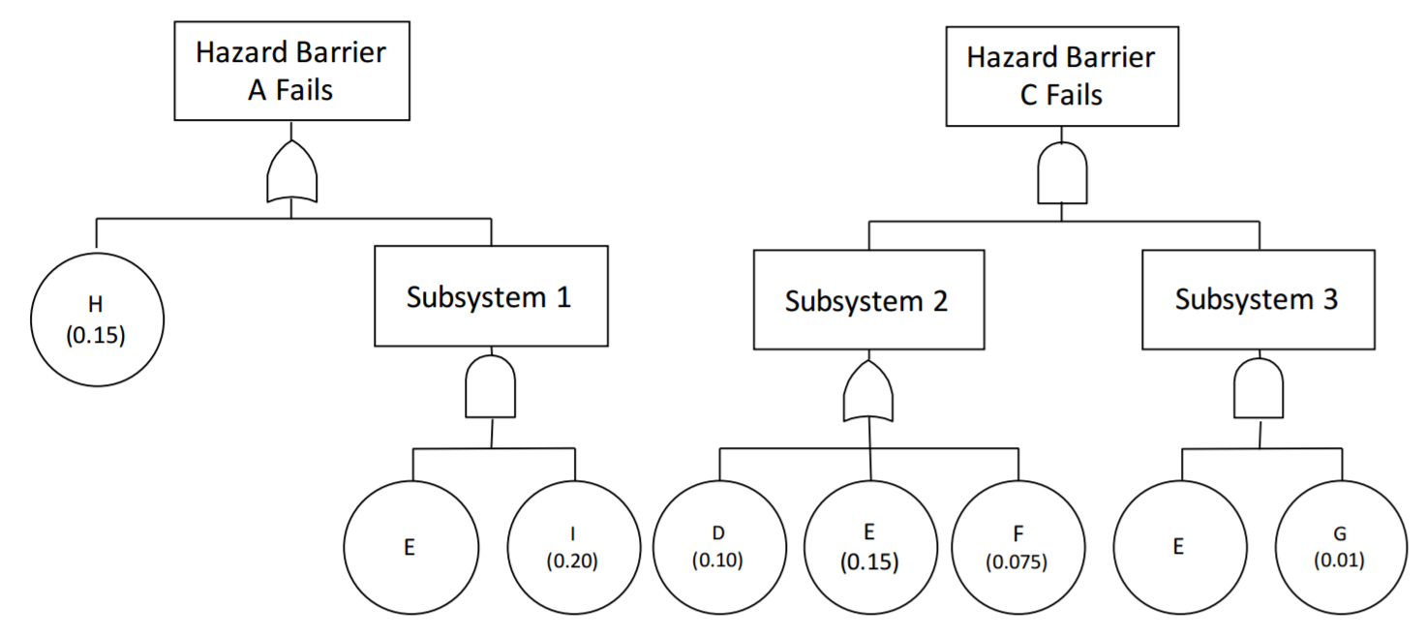

- Calculate the total risk to the system posed by the initiating event, I. Give appropriate units

- Suppose you have a system with a repairable component that experiences in-service failure. When the component fails, it is repaired and run to failure. The interarrival times of failure of the component during the first 100 days of operation are given by: 8 days, 6 days, 10 days, 9 days, 13 days, 16 days, 8 days, and 20 days.

- Assume the failure times follow a homogeneous Poisson process. Estimate the ROCOF
- Now assume that the failure times follow a nonhomogeneous Poisson process according to
Find the MLE of α and β for the given data.

- Does the failure intensity have a time trend (α = 0.05)? Based on this result, which ROCOF from above is more likely correct?

- Suppose you have 10 nominally identical fielded nonrepairable systems. Every time a system fails, it is replaced with a new system. The following failure times have been observed over the first 2000 hours of observation: 750, 900, 1250, 1400, 1525, 1620, 1625, 1700, 1710, 1825, 1905. Assuming the population system failure follows an exponential distribution, estimate the failure rate. Give a two sided 95% confidence interval of the failure rate and the associated confidence interval for the reliability at time t = 3000 hours.

NOTE:
Please use table below as needed.

