16. Calculate the linear regression equation for each of the situations presented below and draw the regression equation into its scatterplot:

a. A researcher hypothesizes a positive relationship between the number of children in a family and the number of televisions a family owns.

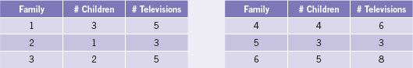

b. Is there a relationship between the amount of time spent watching sports on television and the amount of time actually playing sports? The following data are from a small sample of children who reported their average number of daily hours spent watching sports on television and playing sports.

