Background:
RISK: FREQUENCY DISTRIBUTION, PROBABILITIES, AND EXPECTED VALUE
Histograms (frequency distribution diagram). Consider a repetitive process, for example, driving home from work. You (and your spouse) have noticed that it takes longer to get home sometimes than others. So you want to do an experiment and find out just how long it does take. You record your time to drive home for 6 weeks and get 30 data points. (5 days, 6 weeks). Then you decide to analyze this statistically and see just how frequent the short trips and long trips and medium trips take. The best way to do this is with a frequency diagram. Here is an example of what one looks like:
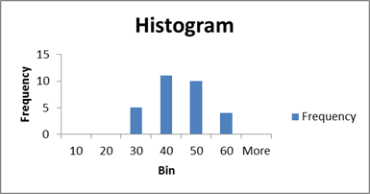
Note that you can analyze this data in more detail. And you can use it determine the Expected Value if you convert the raw frequencies into relative frequencies (probabilities.) The SLP will discuss the concept of Expected Value. In this example, the expected value is 44.3 minutes. Review this problem in the Excel file that you can download.
View an example of a histogram. Download this Excel file with two examples and a Sample Problem: Case 2-Examples-Sample Problem.xlsx (Attached)
PRACTICE: Now try the sample problem with the data in the downloaded Excel file.
- Follow the instructions in the file to create a histogram.
- Check your results by reviewing the last Tab in the file.
You should be ready to do the Case 2 Assignment.

