- Use the ratio $\frac{a_{n}}{a_{n+1}}$ to determine if the following sequences are monotonic increasing, decreasing or neither.
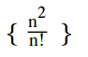

- Use the derivative test to determine if the following sequences are monotonic increasing, decreasing or neither.
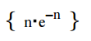

- Use the nth term test to stae if the series converges, diverges, or cannot tell.
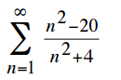

- Use the integral test to determine if the series converges or diverges
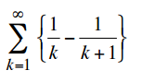

- Use the comparison test test to determine if the series converges or diverges
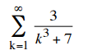

- Use the limit comparison test with the dominant term concept to determine if the series converges or diverges
