- Use implicit differentiation to find dy/dx.
$$xy+x+y=x^{2}y^{2}$$

- Given y = f(u) and u = g(x), find dy/dx = f’(g(x))g’(x).
$$y=u\left(u-1\right), u=x^{2}+x$$

- Find dy/dx
$$y=(4x-5)(4x^{3}-x^{2}+1)$$

- Find the derivative of the function "y" shown below.

$$y=\frac{x^{2}-8x+3}{√x}$$

- One airplane is approaching an airport from the north at 163 km/hr. A second airplane approaches from the east at 261 km/hr. Find the rate at which the distance between the planes changes when the southbound plane is 31 km away from the airport and the westbound plane is 18 km from the airport.

- Find the intervals on which the function shown below is continuous.

$$y=\frac{x+2}{x^{2}-8x+7}$$

- A function f(x), a point c, the limit of f(x) as x approaches c, and a positive number ɛ is given. Find a number δ > 0 such that for all x, 0 < |x – c| < δ ⟶ f(x) - L < ɛ
$$f\left(x\right)=10x-1, L=29, c=3 and ɛ=0.01$$

- Solve the "composite function" problem shown below.

If $f\left(x\right)=\sqrt{x+4 }$ and g(x)=8x-8, find f(g(x)). What is f(g(0))?

- Find the limit shown below, if it exists.

$$\lim_{x→5}{\frac{x^{2}-25}{x^{2}-6x+5}}$$

- Find the area of the shaded region shown below.

F(x)=$x^{3}+x^{2}-6x$ g(x)=6x

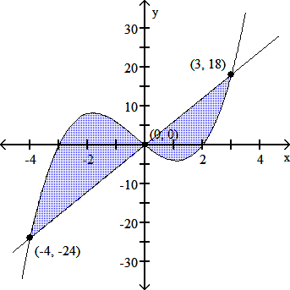

- verify that F(x) is an antiderivative of the integrand f(x) and use Part 2 of the Fundamental Theorem to evaluate the definite integrals.

$$\int_{1}^{4}{3x^{2}dx , F\left(x\right)=X^{3}+2}$$

- use the suggested u to find du and rewrite the integral in terms of u and du. Then find an antiderivative in terms of u , and, finally, rewrite your answer in terms of x .

$$\int{x^{2}{\left(5+x^{3}\right)}^{7} dx u=5+x^{3}}$$

- use the change of variable technique to find an antiderivative in terms of x .

$\int{x\sqrt{1-x^{2}}}$ dx

- evaluate the definite integrals

$$\int_{2}^{5}{\frac{2}{1+x}}dx$$

- sketch the graph of each function and find the area between the graphs of f and g for x in the given interval.

$$f\left(x\right)=4-x^{2}, g\left(x\right)=x+2 and 0≤x≤2$$

