FOR QUESTIONS 1-20 CHOOSE THE RIGHT ANSWER AND CIRCLE THE LETTER CORRESPONDING TO THE ANSWER (20 marks)

1. A slice of bread is squeezed into a little ball, which quantity does not change.

A Mass

B Volume

C Density

D Width

1. A boy measured the height of a laboratory table with a metre rule. Which of the following is most likely to be correct?

A 0.00895m

B 0.0895m

C 0.895m

D 8.95m

1. One gram is equal to

A 10 milligrams

B 100 milligrams

C 1000 milligrams

D 10,000 milligrams

1. An object of mass m, is attached to a spring balance and its weight w is recorded. What will be the result if the object is taken to the moon and weighed there where the gravitational field strength is less?

A Mass = m; Weight greater than w.

B Mass = m; Weight less than w.  
 C Mass greater than m; weight equal to w.

D Mass less than m; weight equal to w.

1. A 3.0-kilogram block is initially at rest on a frictionless, horizontal surface. The block is moved 8.0 meters in 2.0 seconds by the application of a 12-newton horizontal force, as shown in the diagram below.  
     
   What is the average power developed while moving the block?  
     
    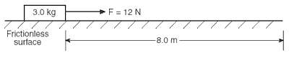

|  |  |  |
| --- | --- | --- |
|  |  |  |

A 24W

B 32W

C 48W

D 96W

1. A 1.2-kilogram block and a 1.8-kilogram block are initially at rest on a frictionless, horizontal surface. When a compressed spring between the blocks is released, the 1.8-kilogram block moves to the right at 2.0 meters per second, as shown.  
     
   What is the speed of the 1.2-kilogram block after the spring is released?

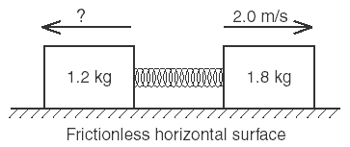

A 1.4 m/s

B 2.0 m/s

C 3.0 m/s

D 3.6 m/s

1. As an object falls freely, its kinetic energy

A increases

B decreases

C remains same

D varies

1. An object weighing 15 newtons is lifted from the ground to a height of 0.22 meter. The increase in the object’s gravitational potential energy is approximately

A 310J

B 32J

C 3.3 J

D 0.34J

|  |
| --- |
|  |
| 1. It is easier to roll a stone up a sloping road than to lift it vertical upwards because |
| |  |  | | --- | --- | |  | A work done in rolling is more than in lifting | |  | B work done in lifting the stone is equal to rolling it | |  | C work done in both is same but the rate of doing work is less in rolling | |  | |  | | --- | | D work done in rolling a stone is less than in lifting it | |  | | |

1. Pascal is the unit used for

A Thrust

B Pressure

C Conductivity

D Frequency

1. If two bodies of different masses, initially at rest, are acted upon by the same force for the same time, then the both bodies acquire the same

A Velocity

B Acceleration

C Momentum

D Kinetic energy

1. Pick out the scalar quantity.

A Force

B Pressure

C Velocity

D Acceleration

1. Inside in an airplane, flying at a high altitude

A The pressure is the same as that outside.

B Normal atmospheric pressure is maintained by the use of air pumps.

C The pressure inside is less than the pressure outside.

D Normal humidity and partial vacuum are maintained.

1. An electrical generator in a science classroom makes a light bulb glow when a student turns a hand crank on the generator. During its operation, this generator converts

A Mechanical energy to electrical energy.

B Electrical energy to mechanical energy

C Electrical energy to chemical energy

D Chemical energy to electrical energy

1. As the block slides across a table, its speed decreases while its temperature increases.

Which two changes occur in the block’s energy as it slides?

A an increase in both kinetic energy and internal energy

B an increase in kinetic energy and a decrease in internal energy

C a decrease in kinetic energy and an increase in internal energy

D a decrease in both kinetic energy and internal energy

1. A 3.0-kilogram mass is attached to a spring having a spring constant of 30. newtons per meter. The mass is pulled 0.20 meter from the spring's equilibrium position and released. What is the maximum kinetic energy achieved by the mass spring system?

A. 0.6 joules

B. 0.06 joules

C. 6 joules

D. 0.006joules

1. A spring stretches 10cm when a mass of 2.0 kg is hung from it. What is its spring constant?
2. 5 kg/m
3. 200N m-1
4. 50kg s-2
5. 20N m-1
6. A pupil has to find the volume of a cork by using a measuring cylinder. The cork floats, so he uses a stone to keep it under the water. He then measures the volume of the stone.  
     
   The results for each stage of the experiment are shown.

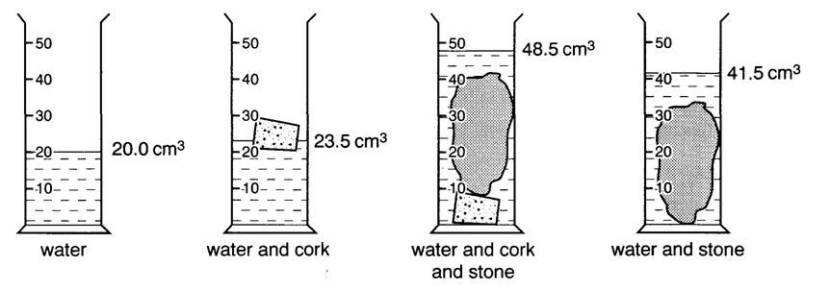

What is the volume of the cork?  
  
A 3.5cm3                     B 7.0cm3                     C 18.0cm3                    D 21.5cm3

19. Which is the odd one out?

A Speed

B Momentum

C Density

D Mass

20.



**SECTION B**

21**.** State the energy changes that occur when: (5 marks)

a) gas is used to boil water in a whistling kettle

______________________________________________________________________________

b) a child blows up a balloon an then releases it, letting it fly around the room.

______________________________________________________________________________

c) a guitarist plays an electric guitar over a public address system.

______________________________________________________________________________

d) a drummer hits the drum.

______________________________________________________________________________

e) a large nail is knocked into a block of wood using a hammer.

______________________________________________________________________________