Group Project #1

Lorena Case Study

EPSY 6302, Sale

Purpose

The purpose of this group project is to have students collaboratively walk through a hypothetical case, applying knowledge and skills learned in Modules 1 – 4. This provides an authentic artifact of students’ ability to work on a real life problem. The case is presented at the end of these instructions.

Format

Response to this assignment using a “Wiki” page that I have established within Blackboard. If you are wondering what a Wiki page looks like, view this one on developmental disabilities. You can edit material on the page as often as you like up until the time of the assignment. This Wiki page will allow me to see the individual contributions of each group member as the page is being built (group members should share equally in the work and will be graded accordingly). Two links to help pages in BB will familiarize you with Wiki’s: Editing a Wiki and Adding Rich Content to a Wiki. There are other on-demand tutorials if you are not familiar with the Wiki. I strongly suggest that you start early by posting an outline so that you can get used to the Wiki functions. If you are having problems, call 956-665-2979, the COLTT help desk.

I am specifically using a Wiki page so that I can see the actual contributions of individual team members and so that you have an opportunity for live collaboration!

Content of the Wiki
- Using Figures 1-1 (4 inclusion options) and 2-1 (6 principles) along with the six IDEA principles in the text, identify how the case study addresses each one, specifically noting the option/principle. For options/principles that seem to be violated, suggest an alternative solution. For principles that are not addressed in the case study, insert the information that would be needed to satisfy the principle or option.

- Analyze the case study from the perspective of the Family Systems Framework (Figure 2-3 and accompanying text). Specify what you can observe about the Inputs, Process, and Outputs. What questions would you ask to gain more information about the family?

- Provide an ecological inventory, in text format, that contains the information from 2 likely environments for Lorena. The environments should be in different Domains Explain the process and likely findings resulting from an ecological inventory for Lorena.

- Imagine conducting a MAPS process for Lorena. Your text explains it but an additional example is provided here. You will not have enough information in the case study above, so you will need to make up her and her team members’ responses to the questions. Make them reasonable given what you know about Lorena. Report the answers to the major questions here.

- Based on the ecological inventory and the results of the MAPS, develop one SMART annual goal and three short term objectives (all related to one of the annual goals) for Lorena. A great resource describing the development of SMART goals can be found here.

- Develop a full instructional sequence including task analysis, prompting and reinforcement sequences and data collection techniques that will be used to teach Lorena one important skill. That skill should be related to one of the objectives previously described in #3 above.
See instructions on outline below.

Suggested Outline
In order for you to cover all areas of this assignment, I suggest that your Wiki page follow an outline similar to the one I have started below:
- Foundations
  - Inclusion options considered and rationale why
add your text here
  - IDEA principles
    - Zero Reject
Lorena’s school did not appear (or did) appear to implement this principle because...etc. etc.
ii. Appropriate Education
Lorena’s school did (or not) provide her with an appropriate education because.....The following should be changed....
iii. Least Restrictive Environment
etc, etc, through the principles

2. Family Systems Framework
a. Inputs
i. Family characteristics
text here
ii. Personal Characteristics
text here
iii. Special challenges
text here
b. Process
etc, etc. through the Family Systems Framework
.
.
.
5. Ecological/environmental Inventory
a. Environment 1 with a specific street address (also note which domain the environment is within)
i. List of all sub environments
ii. List of all activities in one sub environment
iii. List of all skills needed for one activity
b. Environment 2 with a specific street address (also note which domain the environment is within)
i. List of all sub environments
ii. List of all activities in one sub environment
iii. List of all skills needed for one activity
.
.
.
And, etc etc through the all 6 content areas..being sure to BE SPECIFIC!! This is the only way that I can assess that you have grasped the material at an application level!!

Lorena Cuellar Case Study
EPSY 6302, Sale

Lorena Cuellar was a beautiful 9 year old girl who lived in rural south Texas with her grandparents, uncle, mother and two brothers (2 and 5). The language spoken in the home is Spanish and English, primarily Spanish. She loves to cook and can frequently be found after school rolling out cookies. This is a blessing to her stay at home mom because, left alone Lorena would just wander around the house flapping her hands, frequently throw objects and physically taunt her brothers by chasing them and pulling their hair.

Lorena’s mom and her then husband began to notice something was wrong at about 18 months when Lorena would not look into her parents eyes when the spoke to her and did not babble like their nieces and nephews had done. The pediatrician assured them she would mature and “catch up” with her language and socialization. At 2 years 6 months the parents changed Lorena’s pediatrician. The new pediatrician became quite concerned with her development. He had a battery of tests run to make sure there were no physical anomalies such as hearing loss, vision deficits, or structural issues with her vocal cords. There were none. Next, he sent Lorena to a neurologist and a child psychologist. Based on all of the data, Lorena was diagnosed with Autism Spectrum Disorder. Both the father and mother denied this was the case and went to two more sets of pediatricians for second opinions. They received the same answer. And Lorena was beginning to get aggressive toward her brothers. The parents desperately needed respite and tried to enroll Lorena in kindergarten, but the school said she was too severe to benefit and instead provided homebound instruction twice a week. The marriage began deteriorating and a “trial” separation began. At age 7, Lorena’s dad committed suicide.

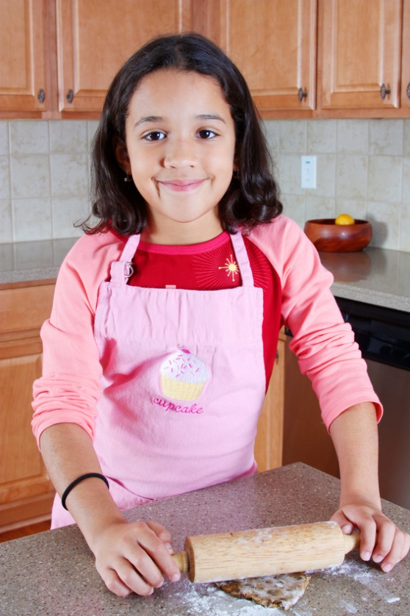
Lorena now only says the words “Mom, I love you”, “No” and “I don’t want to”. It is difficult for her to stay at any task for more than 10 minutes or so, even when her mom or a teacher is beside her. Even though her IEP say’s inclusion full time, she is in an elementary school special classroom for children with severe disabilities. Her mother has asked about this but was told it is in Lorena’s best interest since her performance on a standard IQ test given in English showed she had an IQ of 55. She participates in assemblies and lunch with her peers, with a one on one aide. She tried 3rd grade science time (cooking unit!) in a regular classroom with a one on one aide, but the teacher said she was too distracting to the other children because of her hand flapping. Her curriculum now consists of learning to dress herself, putting together Fisher Price puzzles made for 4 year olds, coloring in outlines of her name and verbally identifying coins.

