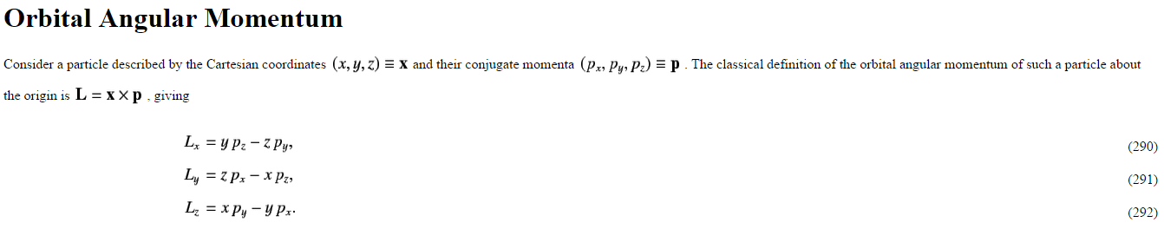

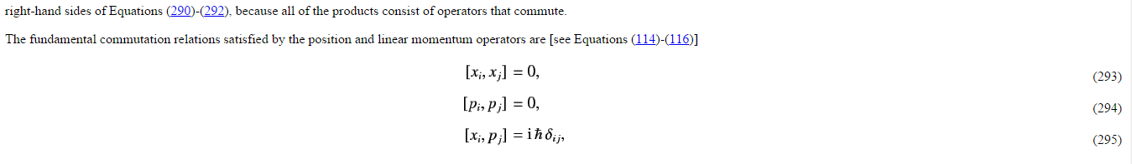

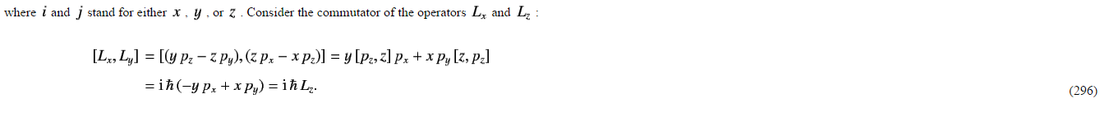
$$y\left[p_{z},z\right]p_{x}+xp_{y}\left[z,p_{z}\right]$$
$$=y\left(p_{z}z-zp_{z}\right)p_{x}+xp_{y}\left(zp_{z}-p_{z}z\right)$$
$$=\left(yp_{z}zp_{x}-yzp_{z}p_{x}\right)+xp_{y}\left(zp_{z}-p_{z}z\right)$$

$$\left[L_{x},L_{y}\right]=\left[\left(yp_{z}-zp_{y}\right),\left(zp_{x}-zp_{z}\right)\right]$$
$$=\left(yp_{z}-zp_{y}\right)\left(zp_{x}-zp_{z}\right)-\left(zp_{x}-zp_{z}\right)\left(yp_{z}-zp_{y}\right)$$
$$=yp_{z}zp_{x}-zp_{y}zp_{x}-zp_{z}yp_{z}+zp_{z}zp_{y}-\left(zp_{x}yp_{z}-zp_{z}yp_{z}-zp_{x}zp_{y}+zp_{z}zp_{y}\right)$$

$$=yp_{z}zp_{x}-zp_{y}zp_{x}-zp_{z}yp_{z}+zp_{z}zp_{y}-zp_{x}yp_{z}+zp_{z}yp_{z}+zp_{x}zp_{y}-zp_{z}zp_{y}$$
$$=yp_{z}zp_{x}-zp_{z}yp_{z}-zp_{x}yp_{z}+zp_{x}zp_{y}$$

I don’t get the relation above in (296). Can you show that it holds. And explain if or if not the order of multiplication does matter or not. And why it would matter if it does. Thank you!

