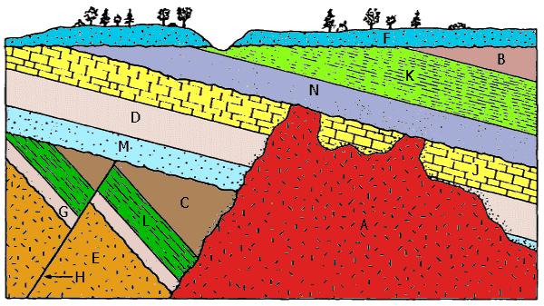

Events # | Letter of Rock Unit/geologic Structure | Relative Dating Principles
Event #20
Event #19
Event #18
Event #17
Event #16
Event #15
Event #14
Event #13
Event #12
Event #11
Event #10
Event #9
Event #8
Event #7
Event #6
Event #5
Event #4
Event #3
Event #2
Event #1

