Diagrams from: US EPA Introduction to Environmental Accounting

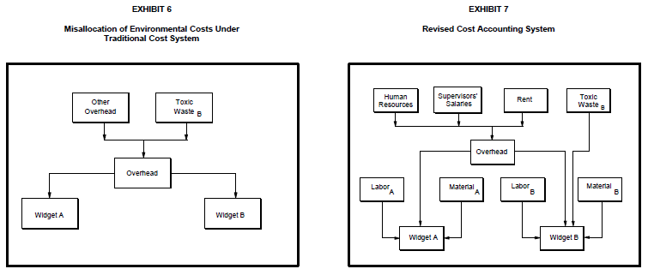
This case study is a brain teaser of sorts that will challenge you to figure out how to move disposal costs from a situation akin to the one in Exhibit 6 to one more like Exhibit 7.
It’s okay to lump all waste disposal costs in overhead for all products (like in Exhibit 6) when those costs are negligible. However, when they are not, then the total costs of different products are inaccurate. One will appear to cost more than it actually does while the one responsible for generating the waste appears to cost less than it does.
Putting large costs (environmental or otherwise) that are generated by one specific process into an overhead account that is allocated across several processes can distort internal estimates of process and product costs.
In this case study, Specialty Glass does not trace the cadmium waste disposal costs directly to the ruby red glass manufacturing process. The arrows in the figure below demonstrate that the overhead cost of the hazardous waste disposal is spread evenly among the different products.
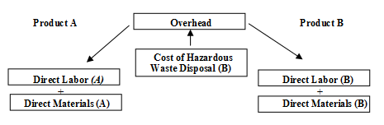

Your challenge is to figure out how to reallocate the disposal cost so that it is attributed only to the product responsible for generating the waste disposal activity.
It is possible that you won’t step into a job where environmental cost reports are generated. You might just have a gut feeling that things could be more efficient than they are and then have to track down the information you need to back up your hunch.
A lot of accounting is logic and analytical thinking. Figuring out what you need to know and figuring out how to get a measurement. I can remember being in an engineering class in grad school and my instructor asking the class on the first day, “If you needed to figure out a flow rate of a stage in a process line, how would you do it?” The answer was simpler than one might think; just get a bucket with a known volume (e.g. a five gallon bucket) and a stop watch and see how fast it fills up to yield gallons/minute. You have to think about what essential information is missing and then figure out how to get it. The math part isn’t hard, but it’s important that you set up your equations properly so that you yield accurate conclusions.
Because this case study builds on itself, I can’t give you help for all the aspects up front like I could with the ABC exercises. You have to work together to try to solve this. Part of it is just figuring out what information you need but don’t have. This is the case in #1 of the discussion question. Some sections of this course really get stuck at the starting line, so hopefully rephrasing it this way will get you pointed in the right direction: Hint: To figure out the production cost for ruby red glass (and therefore how much we are making or losing on it), you need to know two things.

