http://farside.ph.utexas.edu/teaching/em/lectures/node37.html
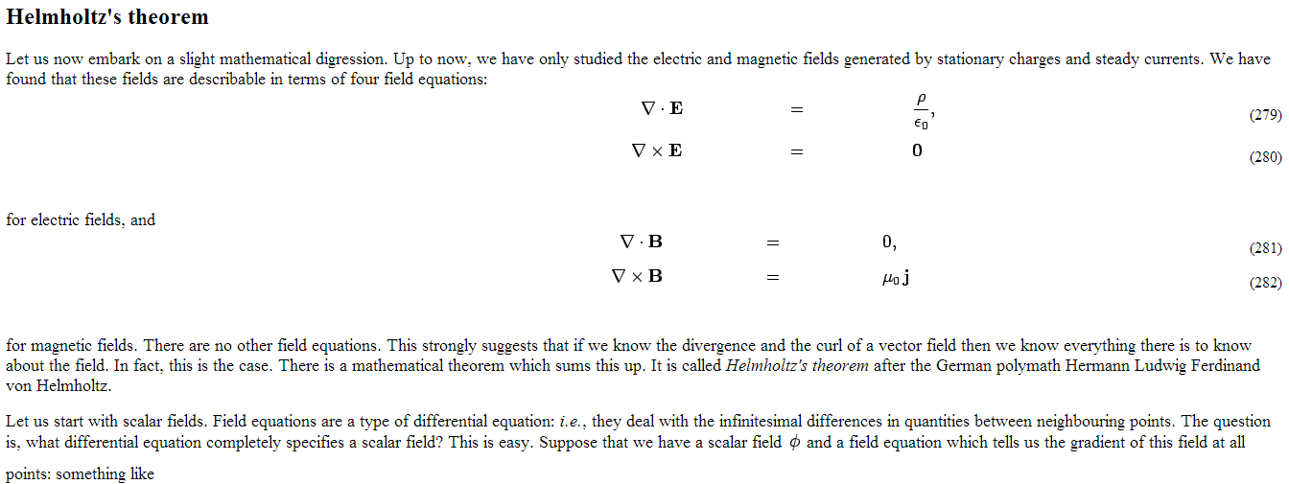
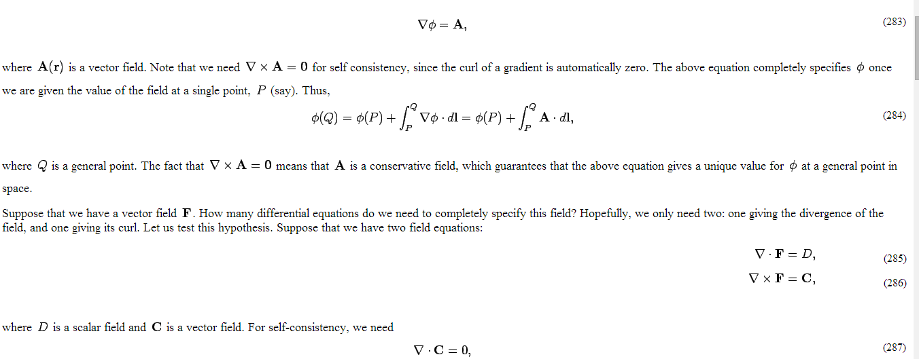
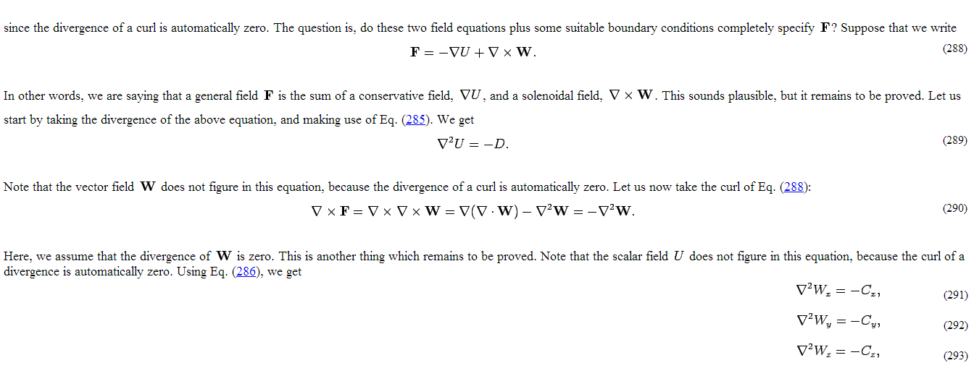
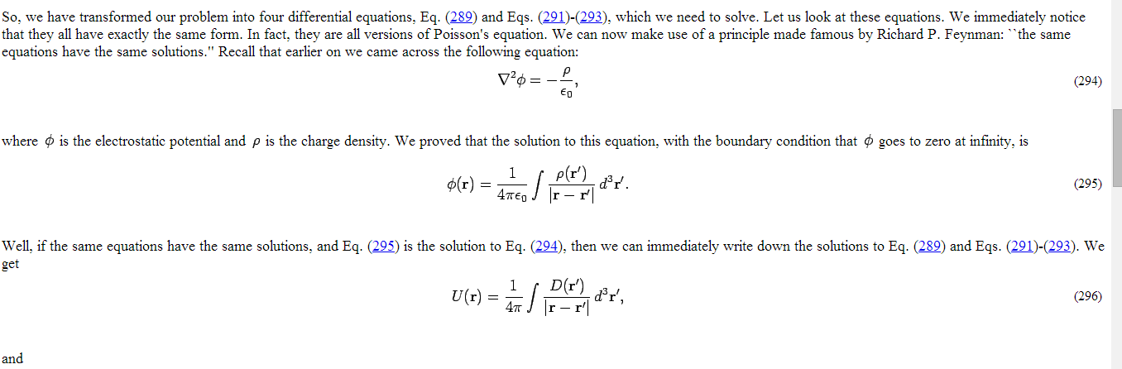
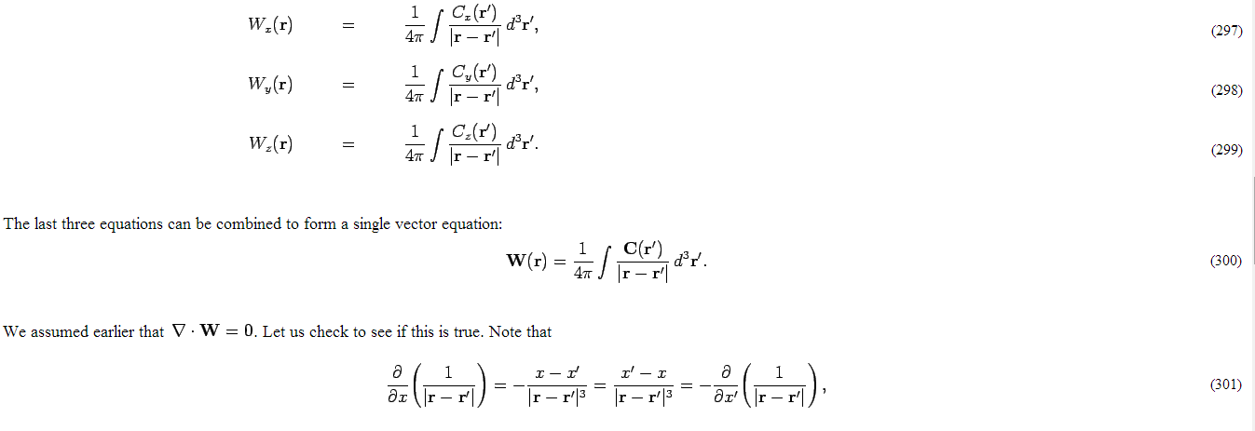
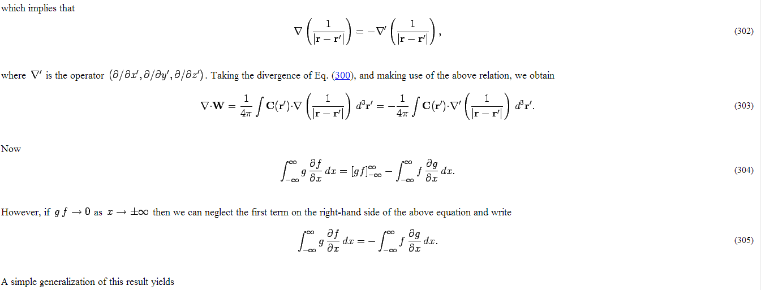
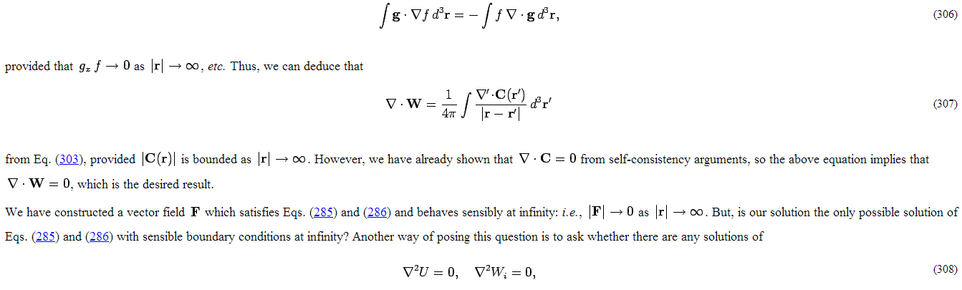
How do they come up with the equations in (308) mathematically? Why do (308) give solutions to (285) and (286). Or why do (308) determine whether (285) and (286) have 1 or more solutions? I don’t wonder about the proof for why the La place (309) introduced as a general equation later in the text has only 1 solution. Thanks
