Question 1.
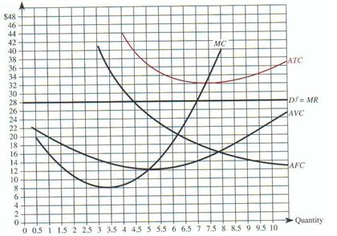

The top graph summarizes the demand and costs for a firm that operates in a perfectly competitive market.

- What level of output should this firm produce in the short run?
- What price should this firm charge in the short run?
- What is the firm’s total cost at this level of output?
- What is the firm’s total variable cost at this level of output?
- What is the firm’s fixed cost at this level of output?
- What is the firm’s profit if it produces this level of output?
- What is the firm’s profit if it shuts down?
- In the long run, should this firm continue to operate or shut down?
Question 2
A firm sells its product in a perfectly competitive market where other firms charge a price of $80 per unit. The firm’s total costs are
C(Q) = 40 + 8Q + 2Q² and its
MC = 8+ 4Q
- How much output should the firm produce in the short run? Hint: Set P = MC and solve for Q
- What price should the firm charge in the short-run?
- What are the firm’s short-run profits?
- What adjustments should be anticipated in the long run?

Instructions: Show all steps.

