One-Way & Factorial ANOVA
For this Project, you will use the “Statistics Class” dataset called Stat_Grades.sav. The Stat_Grades.sav dataset contains data collected about students in three sections of a statistics class taught by an instructor. You will also use SPSS for this project.

HINTS AND HELP

Note: When asked to include the interpretation of the results and final conclusions, be sure to include all results, an interpretation of the meaning of the results, and final conclusions that a common person can understand. Make sure you use complete sentences, paragraph form (single spacing), proper grammar, and correct spelling. Include any SPSS results that you use, but do not include SPSS results that are not part of your solution.

Hint: You are asked to determine “appropriate” tests and methods, and to make calculations. This means that you will have to determine which tests or methods are best and why.

Remember to always show all of your work and each of your steps.
For each question, follow the appropriate steps.
1) Write the hypothesis - Construct the null(s) and alternative(s) clearly and appropriately.
3) Run the appropriate SPSS test(s) and include the appropriate results
4) Explain and evaluate the SPSS results
5) Write a complete and paragraph form conclusion that can be understood by a normal non-statistical person.

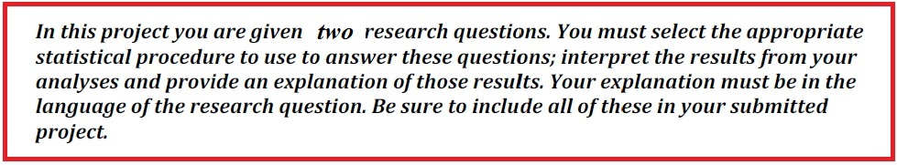

Research Project Instructions: Using the Statistics Class dataset called “Stat_Grades.sav”, answer the following. Use alpha = .05

1. Compare the different Ethnicities of students in the Stat_Grades.sav class to determine if there is a statistically significant difference in the average Final Examination points between the different ethnicities. Be sure to state the hypothesis, state Ho and Ha, include and explain all SPSS results, and write final conclusions for the full results of the test. Include Post Hoc results and the plot. Be sure that your final conclusions are written in common terms for an average person to understand.

Place your response here. Use as much space as you need.

2. Extend the hypothesis from number one above. Compare the different ethnicities of students in the Stat_Grades.sav class and the genders to determine if there is a statistically significant difference in the average Final Examination points between the different ethnicities and different genders. Be sure to state the hypothesis, state all Ho and Ha, include and explain all SPSS results, and write final conclusions for the full results of the test. Include Post Hoc results, note any interactions and whether they are significant, and include and explain the plot. Be sure that your final conclusions are written in common terms for an average person to understand.

Place your response here. Use as much space as you need.

