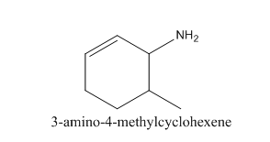
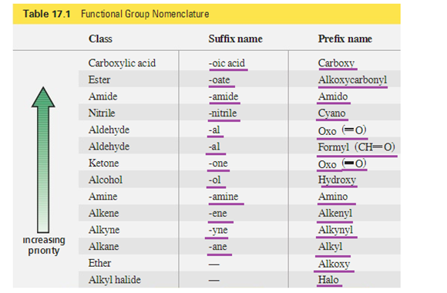
The priority of amine is higher than alkene still the compound above uses hexene as suffix name? What are then priority used for? And how does one determine the rank of the suffix ending? Do you have a general table or explanation?

