1.
Consider the following constraints from a linear programming problem:
2X + Y 200
X + 2Y 200
X, Y 0
If these are the only constraints, which of the following points (X,Y) cannot be the optimal solution?

- (0, 0)
- (0, 200)
- (0,100)
- (100, 0)
- (66.67, 66.67)

2.

Activity | Immediate Predecessor | Time | ES | EF | LS | LF
A | --- | 4 | 0 | 4 | 6 | 10
B | ---- | 5 | 0 | 5 | 0 | 5
C | A | 3 | 4 | 7 | 10 | 13
D | B | 8 | 5 | 13 | 5 | 13
E | B | 2 | 5 | 7 | 16 | 18
F | C,D | 3 | 13 | 16 | 15 | 18
G | C,D | 7 | 13 | 20 | 13 | 20
H | E,F | 2 | 16 | 18 | 18 | 20

How long could activity E be delayed without delaying the completion of the project?
7
16
11
18
None of these
3.

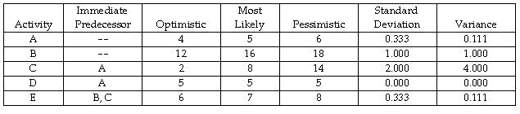
According to above table, there are five activities in a PERT project. If the normal distribution were used to find the probability of finishing this project in 24 weeks or fewer, what mean and variance would be used?
20 and 4.222
30 and 5.222
20 and 5.222
30 and 4.222
22.667 and 1.111

4.

Time in weeks:
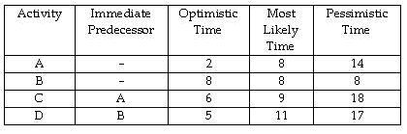
According to above table, there are four activities in the project. Assume the normal distribution is appropriate to use to determine the probability of finishing by a particular time. What is the probability that the project is finished in 16 weeks or fewer? (Round to two decimals.)
0.07
0.93
0.43
0.77
None of these
5.

Over a 10-day period, the total number of complaints was 360. The company wishes to develop a control chart for the number of complaints. What would the upper control limit on the number of complaints per day be for a 3 sigma (99.7%) control chart?
- 12
- 42
- 48
- 54
- None of these

6.
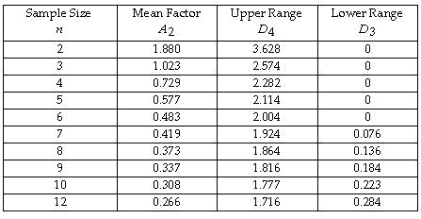

The overall average for the samples is 36 ounces. Each sample contains eight bags. The average range is 1.3 ounces. The lower control chart limit for the sample averages would be

36.3730.
36.4849.
35.6270.
35.5150.
None of these
7.

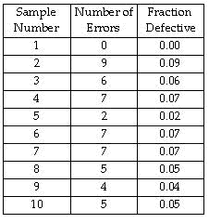

The c-chart is be useful when we
take a number of measurements and compute the average.
take a number of measurements and compute the ranges.
find the fraction of the production lot defective.
find the number of defective items in a production lot.
None of these

8. A quality control program is being developed for batteries. The percent defective for these in the past has been 3%. If a sample size of 120 is taken, what would the 99.7% upper control chart limit be?
0.0812
0.0767
0.0611
0.0307
0.0471

