The causal solution$f(x, t)$ of the one-dimensional diffusion equation with source term f
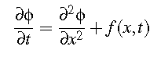
(1)
is given by
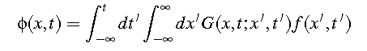
(2)

where $G(x, t; x^{'}, t')$ is the causal Green function satisfying
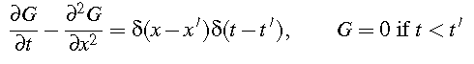
(3)

a) Change variables in (3) to $τ=t-t'$, $z = x-x’$. Letting $G(z, τ)= g(z, τ)H(τ)$ with $H$ the Heaviside step function, show (3) is solved if $g$ satisfies
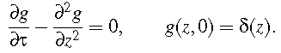
(4)
Solve by Fourier transforming with respect to the position variable. Hence obtain an expression for $G\left(x, t; x^{'}, t^{'}\right).$
b) The temperature $Φ(x, t)$ of a long uniform insulating metal rod satisfies
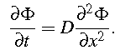

A heating element is used to create an initial temperature distribution $Φ\left(x, 0\right)=$ $T_{0}e^{-λx^{2}}.$ Writing $ϕ\left(x, t\right)=Φ\left(x, t\right)H(t)$ obtain an equation for $ϕ$, and combining (1), (2) and the answer to a) identify the temperature variation at the center of the rod, $Φ(0, t)$.

$H\left(x\right)=1$ for $x>0$, =1/2 for $x=0$ and $=0$ for$x<0$ and satisfies $dH(x)/dx = δ(x).$

