Statistical Calculations

- Use the data in the table below to
  - Prepare a frequency distribution of the respondents' ages
  - Cross-tabulate the respondents' genders with cola preference
  - Identify any outliers

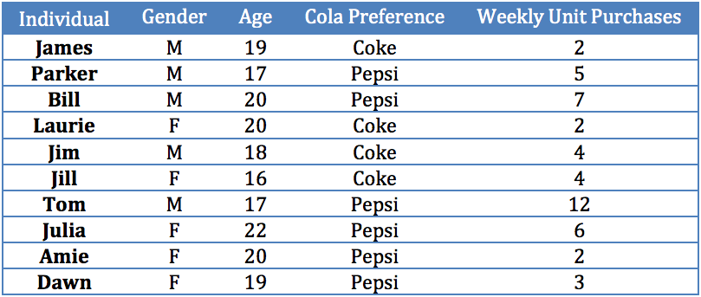

- Data on the average size of soda (in ounces) at all 30 major league baseball parks are as follows: 14, 18, 20, 16, 16, 12, 14, 16, 14, 16, 16, 16, 14, 32, 16, 20, 12, 16, 20, 12, 16, 16, 24, 16, 16, 14, 14, 12, 14, 20. Compare descriptive statistics for this variable including a box and whisker plot. Comment on the results.

- A sales force received some management-by-objectives training. Are the before/after mean scores for salespeople's job performance statistically significant at the 0.05 level? The results from a sample of employees are as follows
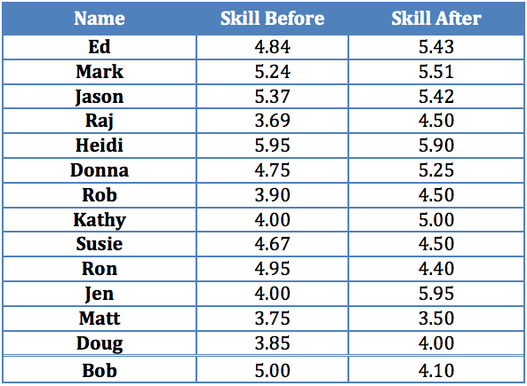

- In an experiment with wholesalers, a researcher manipulated perception of task difficulty and measured level of aspiration for performing the task a second time. Group 1 was told the task was very difficult, group 2 was told the task was somewhat difficult but attainable, and group 3 was told the task was easy. Perform an ANOVA of the resulting data
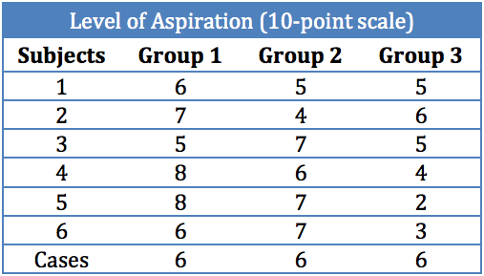

- The table below gives a basketball team's season-ticket sales, percentage of games won, and number of active alumni for the years 2002-2011
  - Compute a correlation matrix for the variables. A software statistical package is recommended. Interpret the correlation between each pair of variables
  - Estimate a regression model for sales = percentage of games won
  - Estimate a regression model for sales = number of active alumni
  - If sales is the dependent variable, which of the two independent variables do you think explains sales better? Explain.
