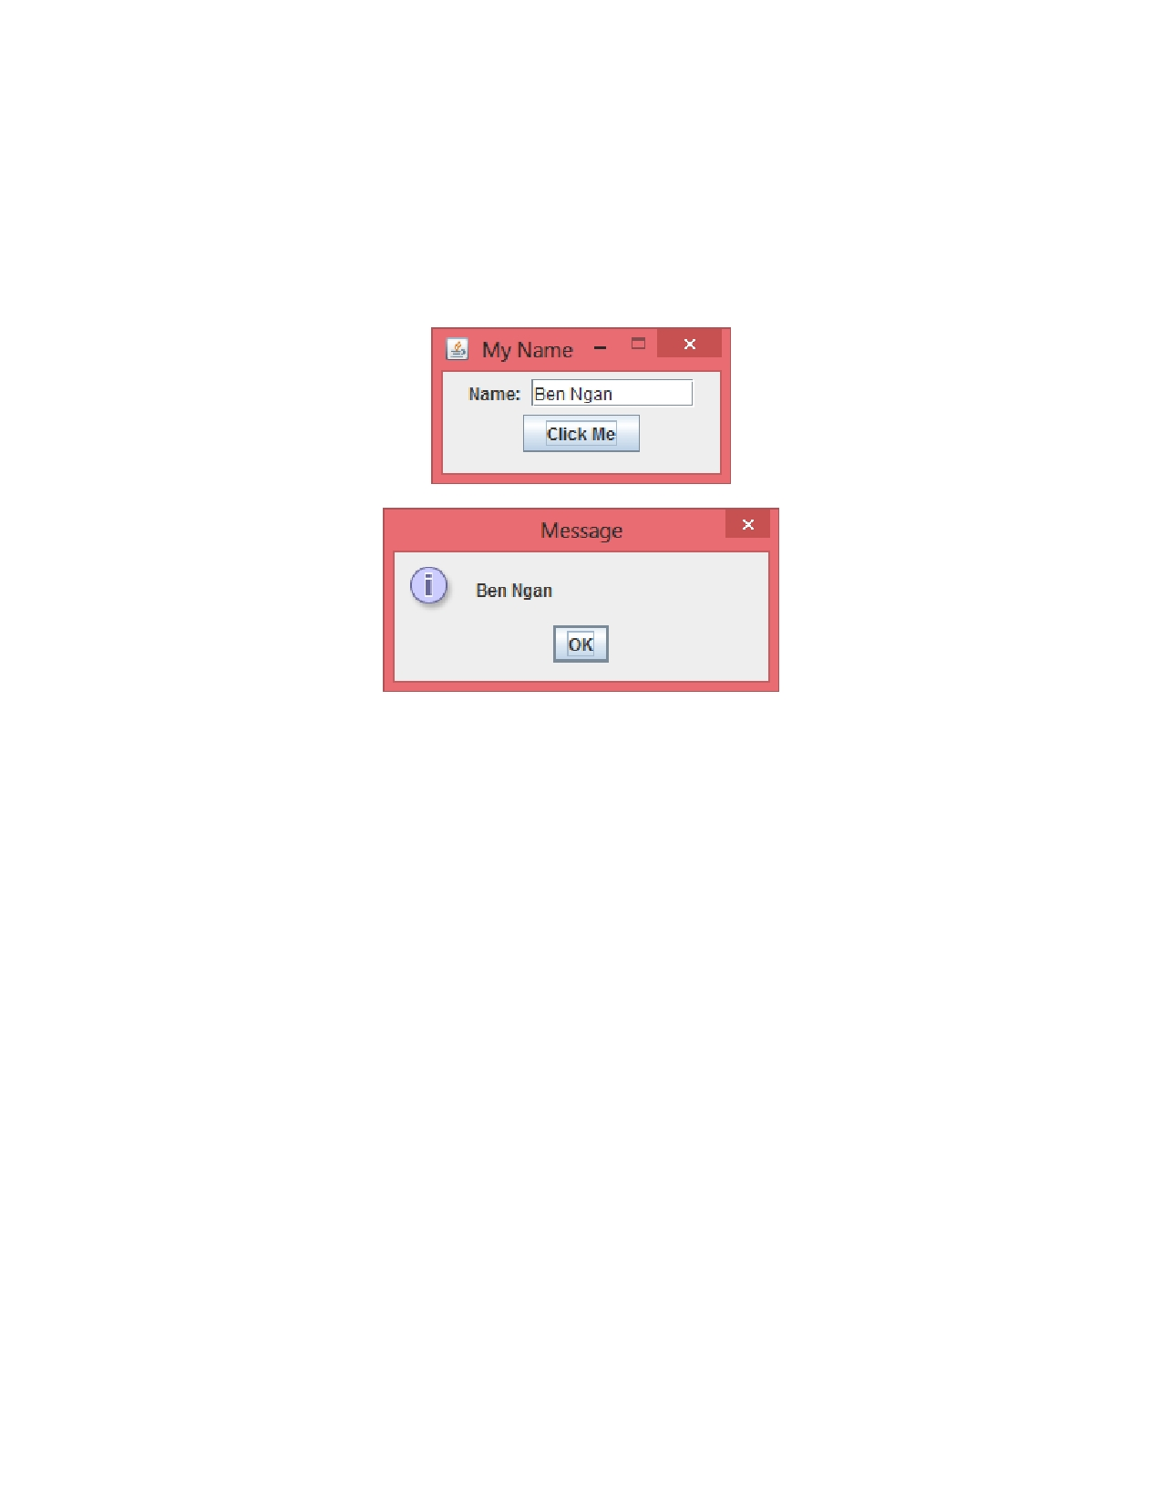

Problem Description:

Write a simple GUI program that displays your name in the JOptionPane dialog box when the button "Click Me" is pressed. Set the size to 200 by 100. If no name is entered, no dialog box is shown up. Make the frame visible and exit on close but not resizable.

Submission:
1. Submit your source codes, a frame and an application class, and the corresponding program output.

