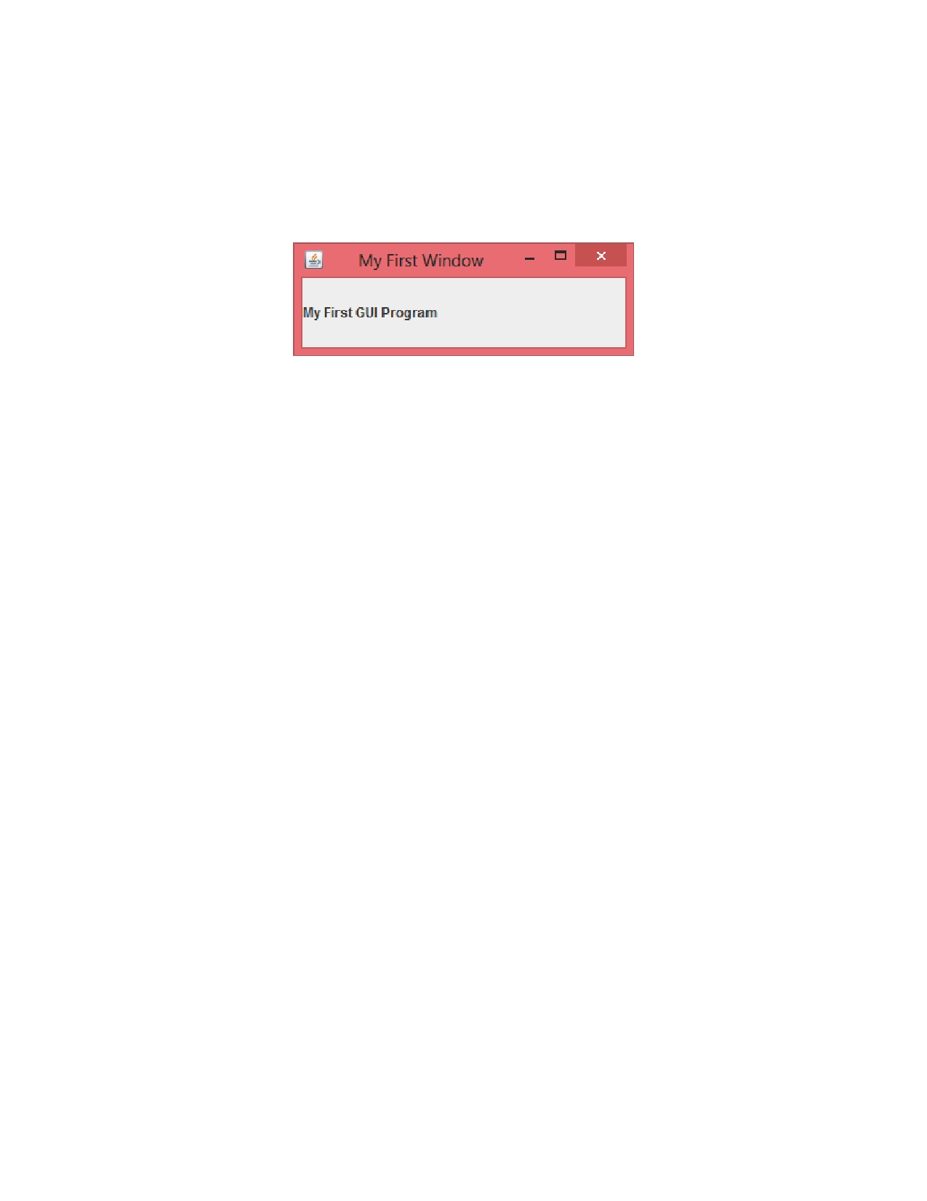

Problem Description:

Write a simple GUI program that displays a single frame with the title "My First Window" with the label "My First GUI Program". Set the size to 300 by 100. Make the frame visible and exit on close.

Submit your source code and the corresponding program output.

