For this assignment, you will be preparing a statement of cash flows, using the indirect method. Information for the statement is given below. Please turn in your solution to the dropbox provided.
Needed Information:
Presented below are the comparative balance sheets for Gordon Company at December 31, 2013 and 2012.
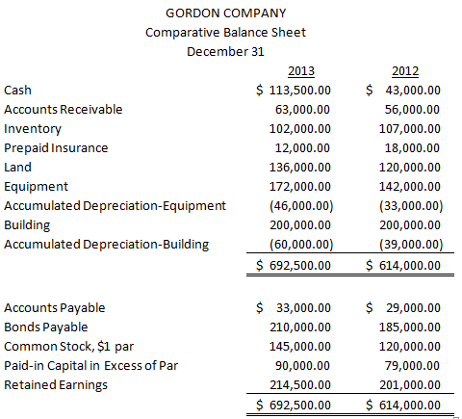
Additional Information:
- Land was sold for $28,000 cash. Land was also obtained through issuance of common stock (see item 2). These are the only two transactions impacting land.
- Land was obtained by issuing 25,000 shares of $1 par value common stock. The land had a fair value of $36,000.
- Cash dividends of $86,500 were paid.
- Net income for 2013 was $100,000.
- Equipment was purchased for cash. In addition, equipment costing $32,000 with a book value of $12,000 was sold for $9,000 cash.

