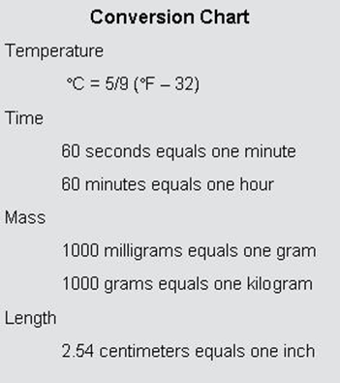
Exercise 3: Conversion
For each of the following, convert each value into the designated units.

- 46,756,790 mg = _______ kg
- 5.6 hours = ________ seconds
- 13.5 cm = ________ inches
- 47 °C = _______ °F

Exercise 4: Accuracy and Precision
- During gym class, four students decided to see if they could beat the norm of 45 sit-ups in a minute. The first student did 64 sit-ups, the second did 69, the third did 65, and the fourth did 67. 2. The average score for the 5th grade math test is 89.5. The top 4th graders took the test and scored 89, 93, 91 and 87.
- Yesterday the temperature was 89 °F, tomorrow it’s supposed to be 88°F and the next day it’s supposed to be 90°F, even though the average for September is only 75°F degrees!
- Four friends decided to go out and play horseshoes. They took a picture of their results shown to the right:

- A local grocery store was holding a contest to see who could most closely guess the number of pennies that they had inside a large jar. The first six people guessed the numbers 735, 209, 390, 300, 1005 and 689. The grocery clerk said the jar actually contains 568 pennies.

