After doing some research your collect the following data related to overhead (OHD) and possible causal factors:
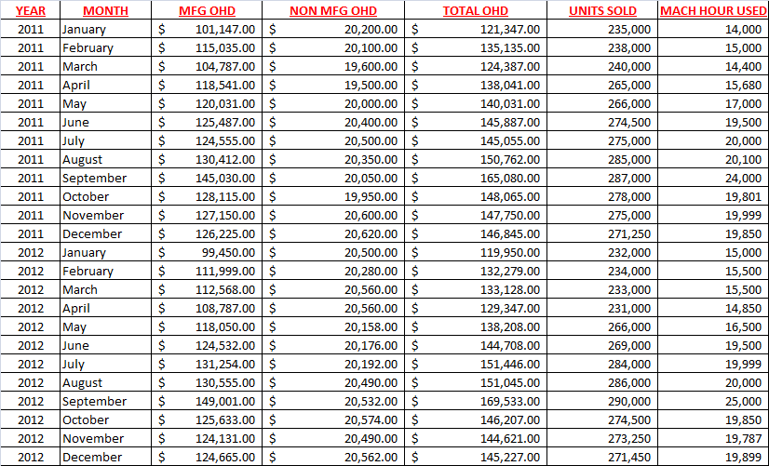
Requirement #1 Using the data above, which has also been provided electronically in Excel, run the following regression analyses:
- Linear regression analyzing total overhead cost and units sold
- Linear regression analyzing total overhead cost and machine hours used
- Multiple regression analysis analyzing total overhead cost along with both units sold and machine hours used
Requirement #2 Based on the results from the three regression analyses determine which correlation provides the best estimate of the total cost equation. Explain why you selected the correlation that you did.
Requirement #3 Write out the total cost equation using the results from the multiple regression test.
Requirement #4 Create a “Contribution” formatted income statement using the results from the multiple regression test. Use the following additional information regarding machine hours, used by each product, which has also been provided in Excel electronically:
Reference the following sales volumes, by product, for your cost allocation related to units sold:
Use the following template as a guide for the format of your “Contribution” Income Statement:
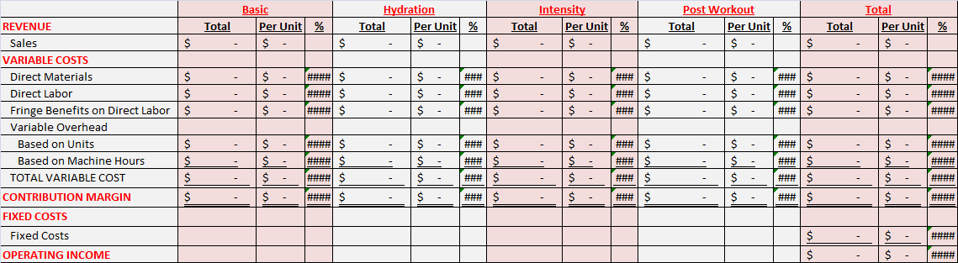
Requirement #5 Compute the following:
- Break-even point in units & Break-even point in sales dollars
- Targeted profit point in units (use $50,000 as your targeted profit point)
- Margin of Safety
Requirement #6 A new customers has surfaced. That customer has asked you to consider producing a special one-time order for them. This special order would require a modification to the recipe that will slightly increase the variable cost per unit. Furthermore, there would be a small fixed cost addition. The details for the order as follows:
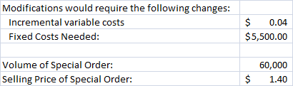
Conduct a differential analysis regarding this special order. Would you accept this order under the conditions provided? Explain and defend your position.
Requirement #7: Your management team has asked you to consider investing in a new piece of equipment. The details of that investment opportunity are following: 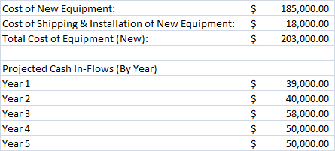
The discount rate for this project is 5%. Compute the following:
- Net Present Value & Internal Rate of Return
Would you recommend investing in this new piece of equipment? Explain and defend your position.

