Radioactivity and Nuclear Chemistry Part II
- What is the correct name for the compound depicted in the skeletal structure below?
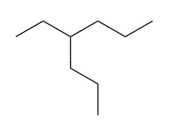
- Which of the following is a structural isomer of 2-methylpentane? Choose from:
cyclohexane
2-methyloctane
2,2-dimethylbutane
3-ethylheptane
n-butane
- How many of the carbons in the molecule depicted below are chiral?
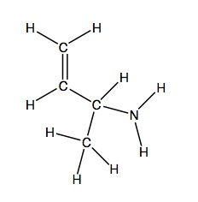
- What kind of reaction converts an unsaturated hydrocarbon into a saturated one? Choose from:
substitution of a hydrogen with a halogen under high energy light
a hydrogenation reaction in the presence of a catalyst
addition of a halogen to an alkene
combustion reaction with oxygen
- How would the compound shown below be classified?
