- Are commodity prices reflective of demand and supply? Write a 4 to 5 page paper in which you analyze one of the below markets. Look up the historical prices of the commodity of your choosing. Consider what factors of demand and supply have caused changes in the commodity price. Explain how you would expect global news/events to affect the market, and then see if the commodity prices moved as you expected.
- Silver
- Soybean
- Uranium
- Lumber
- Coffee

Step One: Choose a commodity and do some research.
- http://money.cnn.com/data/commodities/
- http://markets.ft.com/research/Markets/Commodities
Step two: Write an outline.
- Example: Cocoa Market
- Bad weather
  - Economic theory tells us that bad weather may decrease the supply of a product, resulting in a higher price.
  - Bad weather was recently reported in the Ivory Coast.
    - The Wall Street Journal reported that the bad weather resulted in prices rising 7%.
- Step three: Turn the outline into a Five Paragraph Essay
- Step four: Compose a Rough Draft
- Step Five: Complete your Final Paper

Example – Cocoa
What happened to cause these peaks/ troughs?
USDA changes standards for cocoa exporters

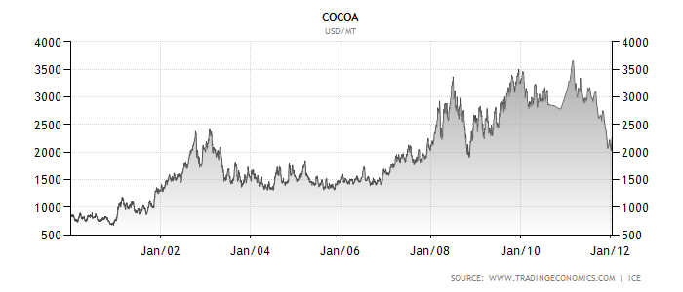
Bad Weather in Ivory Coast
Unusually good weather leads to a bumper crop

