1. Write any integral from the next page that requires a constant of integration after calculating the antiderivative. (Include ALL notation. Do not evaluate the integral here.)
2. Write any integral from the next page that requires the Fundamental Theorem of Calculus to evaluate an area under a curve. (Include ALL notation. Do not evaluate the integral here.)
3. For the following graph, determine the interval(s) of *x*-values (from *x* = *a* to *x* = *b*) that have a definite integral of *positive* area or *negative* area from:
   1. [1, 3]
   2. [–2, –1]
   3. [–1, 1]

**Just answer *positive area* or *negative area*!**

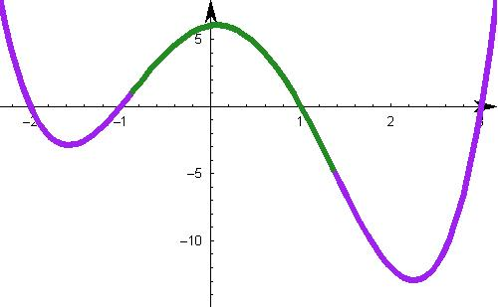

For Questions #5 – 10, evaluate the following integrals. Use *u*-substitution and the Fundamental Theorem of Calculus only when necessary. You do not have to simplify any indefinite integral.

1. 
2. 
3. 
4. 
5. 
6. 
7. Determine the area of the region bounded by eq0016Memptyempty and eq0017M based on the graph below.  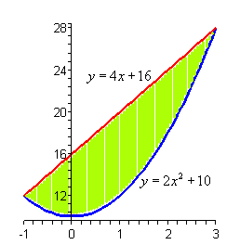
8. Suppose the rate of change of production of a regular worker at a factory is given by



where *p* is the is the number of units the worker produces in *t* hours. Also, after 2 hours, 90 units will have been produced. What is the original production function (with the appropriate value of +C)?

1. A store finds that its sales revenue changes at a rate given by  dollars per day, where *x* is the number of days after an advertising campaign ends. To determine the long-term effects of the campaign, find the total sales for the **first week** after the campaign ends (use the number of *days* for the first week).
2. A casino wants to determine how much of an income stream comes from a certain slot machine. Suppose that money flows continuously into one of the slot machines and grows at a rate (in thousands of dollars) given by *A’*(*t*) = 0.10*e*0.1*t* , where *t* is time in hours. Find the total amount that accumulates in the slot machine during its first 10 hours of operation, if no money is paid out.
3. The cost for producing flat-screen televisions can fluctuate depending on parts supplies, price of transportation, and other factors. Suppose that the marginal cost in dollars for making flat-screen televisions is given by *C’*(*x*) = 400 + *x* + 0.3*x*2, where *x* is the number of units. What is the **average value** of *C*(*x*) for 0 to 10 flat-screen televisions?
4. CONSUMER SURPLUS/DEMAND