Scenario
The board liked the analysis you did on valuation and agreed to proceed with the expansion plan. Your CFO, investment bankers, and consultants have all been working on the cost and benefits of various expansion options. They have agreed on an option that will see simultaneous expansion into five domestic markets (Chicago, Dallas, Miami, NY, and Charlotte), Germany and Brazil. The CFO has developed cost and benefits of the scenario in a spreadsheet and has asked you to review it.
Look at the spreadsheet and use present value analysis to discount the cash flows. Include the calculations for net income, operating cash flows, free cash flows and the present value cash flows and NPV in your spreadsheet. Does the project have a positive or negative NPV? What are the implications for CPI and its shareholders if there is a positive NPV or a negative NPV. Is the dollar value of the NPV important in light of the expenditure? In making the final decision what kind of economic assumptions do you think the CEO had to make. Articulate the economic and political risk with the strategy and list options to overcome. How will this decision affect the share price and the value of the company? In light of all this information, would you support the above mentioned option for expansion? Why or why not
The CEO's spreadsheet
Year |  | 2011 | 2012 | 2013 | 2014 | 2015 | 2016 | 2017
Cost of Capital |  |  | 6% | 6% | 7% | 8% | 8% | 7%
(US$ in millions)
Revenue |  |  | $30.10 | $34.20 | $38.10 | $40.40 | $45.60 | $50.00
Selling, General, Admin |  |  | ($16.10) | ($17.20) | ($18.90) | ($19.50) | ($21.40) | ($24.30)
Depreciation |  |  | ($4.10) | ($4.40) | ($4.80) | ($4.90) | ($5.30) | ($5.70)
Interest Expense |  |  | ($0.45) | ($0.56) | ($0.69) | ($0.73) | ($0.78) | ($0.81)
Taxes |  |  | ($1.10) | ($1.30) | ($1.70) | ($1.90) | ($2.00) | ($2.10)
Increase in fixed assets |  |  | ($1.30) | ($2.40) | ($0.90) | $0.00 | ($4.90) | ($2.10)

Initial Capital Expenditure | ($18.00)

Students need to calculate the following
Net Income
Depreciation (provided) |  | ($4.10) | ($4.40) | ($4.80) | ($4.90) | ($5.30) | ($5.70)
Operating Cash Flows (FV) |  | $4.25 | $6.34 | $7.21 | $8.47 | $10.82 | $11.39
Increase in fixed assets (provided) |  | ($1.30) | ($2.40) | ($0.90) | $0.00 | ($4.90) | ($2.10)

Pvif factor |  | 0.943 | 0.89 | 0.816 | 0.735 | 0.681 | 0.666
PV Cash flows

Value of future flows
Initial expenditure
NPV
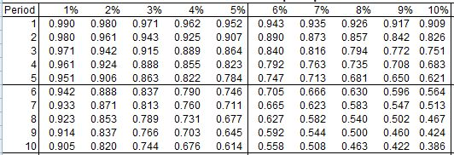
Computed the correct Net Present Value. Articulated the economic and political risk. List options to overcome risk. Form appropriate questions on economic assumptions. Make the correct decision on whether or not to adopt the strategy. Provide the NPV, IRR, MIRR, and Payback Ratio.

