** Below are the questions I am having the most difficulty with. Thank you!

A.)
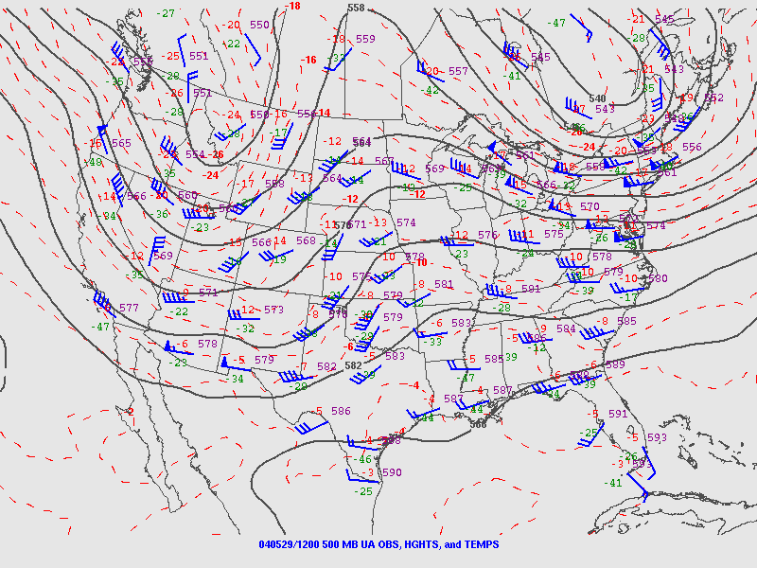

B.)
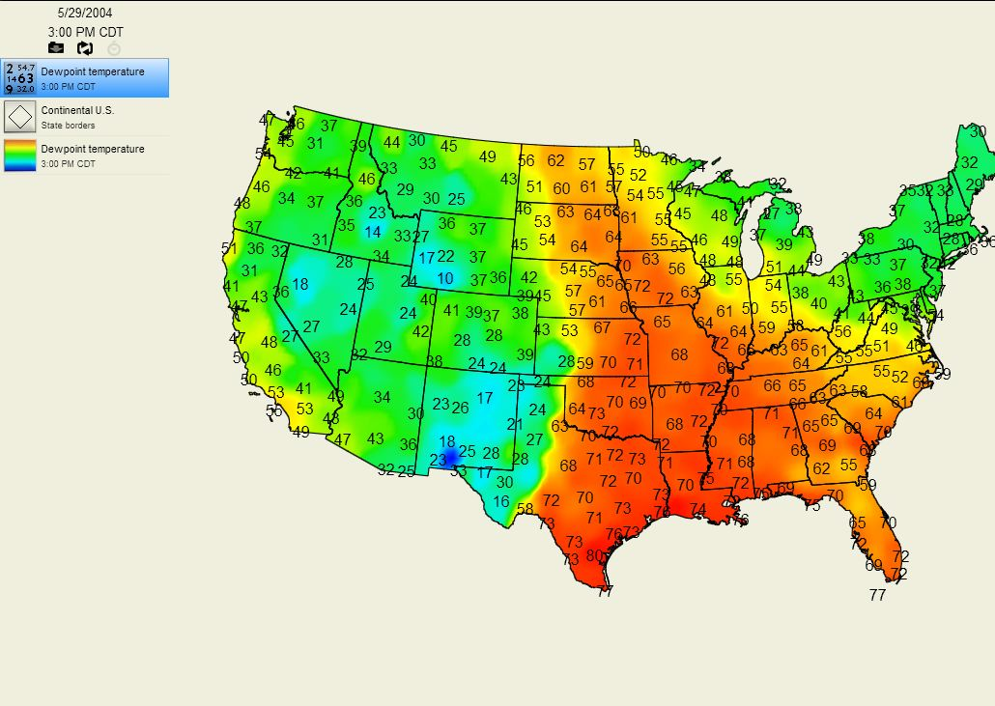

C.)

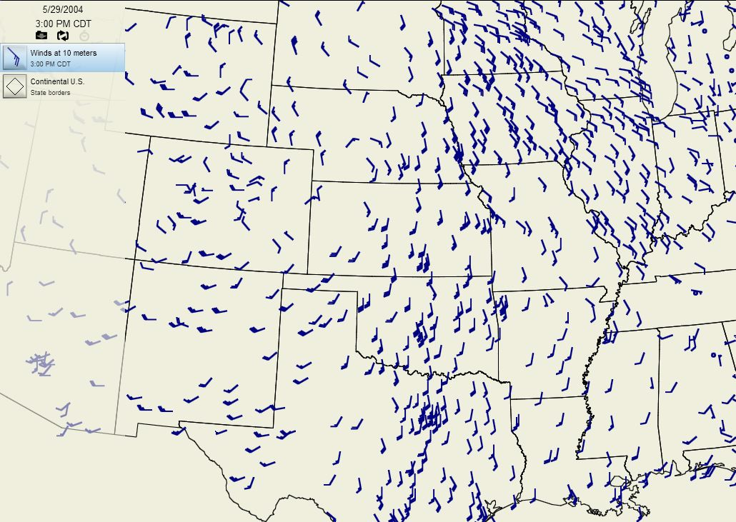

5) Using the 500 mb map. Locate the trough(s) and ridge(s).
9) Where across the US is there enough moisture to sustain severe weather?
10) Using the wind map, is there a boundary in the central part of the U.S. If so, where is it located?
22) Given the answers from the previous questions, where would you expect severe weather to occur? Be specific, include the states and where in the state you would expect this weather.
27) Why is wind shear important to severe thunderstorms?

