EXERCISE 27 SIMPLE LINEAR REGRESSION

RESEARCH ARTICLE
Source: LeFlore, J. L., Engle, W. D., & Rosenfeld, C. (2000). Determinants of blood pressure in very low birth weight neonates: Lack of effect of antenatal steroids. Early Human Development, 59 (1), 37–50.

Introduction
LeFlore, Engle, and Rosenfeld (2000) conducted a retrospective, cohort study (Group 1 received antenatal steroids [n = 70]) with matched controls (Group II did not receive antenatal steroids [n = 46]) to examine the effect of antenatal steroids on neonatal blood pressure (BP) in the first 72 hours of life in very low birth weight (VLBW) neonates. Additionally, the effect of other perinatal factors on BP were studied, which included estimated gestational age (EGA), birth weight (BW), and postnatal age. The results indicate that there are positive linear relationships between BP and BW, BP and EGA, and BP and postnatal age.

Relevant Study Results
BP for Group I and Group II were compared over the first 72 hours of the neonate's life. Since there were no significant differences in initial and subsequent measurements of BP between the groups, subsequent analyses were performed with the groups combined (n = 116). To assess the effect of BW on BP, the infants were grouped into those with BW ≤ 1,000 grams (n = 36) and those with BW 1,001–1,500 grams (n = 80). The researchers displayed the results of their analyses in figures. Figure 2 displays the relationships between postnatal age in hours and 3 BPs, systolic BP (SBP), diastolic BP (DBP), and mean BP (MBP), for infants with BW ≤ 1,000 grams. Figure 3 displays the relationship between postnatal age in hours and SBP, DBP, and MBP for infants with a BW 1,001–1,500 grams.

FIGURE 2 Change in (A) systolic blood pressure (SBP), (B) diastolic blood pressure (DBP), and (C) mean blood pressure (MBP) in neonates ≤ 1,000 grams birth weight (n = 36) during the initial 72 hours postnatal. Lines represent means and 95% confidence intervals (p < 0.0001). Equations for lines of best fit were: SBP = 43.2 + 0.17x; DBP = 25.8 + 0.13x; MBP = 32.9 + 0.14x. In each instance, the y intercept was significantly lower (p < 0.001) than the value for comparable lines of best fit in infants with birth weights 1,001–1,500 grams; however, no significant differences in slopes for the lines of best fit were observed between the two birth weight groups.
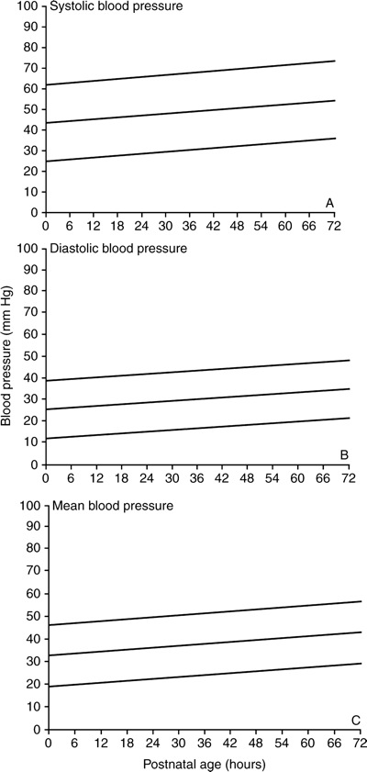
LeFlore, J. L., Engle, W. D., & Rosenfeld, C. (2000). Determinants of blood pressure in very low birth weight neonates: Lack of effect of antenatal steroids. Early Human Development, 59 (1), p. 44

FIGURE 3 Change in (A) systolic blood pressure (SBP), (B) diastolic blood pressure (DBP), and (C) mean blood pressure (MBP) in neonates 1,001–1,500 grams birth weight (n = 80) during the initial 72 hours postnatal. Lines represent means and 95% confidence intervals (p < 0.0001). Equations for lines of best fit were: SBP = 50.3 + 0.12x; DBP = 30.4 + 0.11x and MBP = 37.4 + 0.12x. In each instance, the y intercept was significantly greater (p < 0.001) than the value for comparable lines of best fit in infants with birth weight ≤1,000 grams; however, no significant differences in the slopes for the lines of best fit were observed between the two birth weight groups. LeFlore, J. L., Engle, W. D., & Rosenfeld, C. (2000). Determinants of blood pressure in very low birth weight neonates: Lack of effect of antenatal steroids. Early Human Development, 59 (1), p. 45.
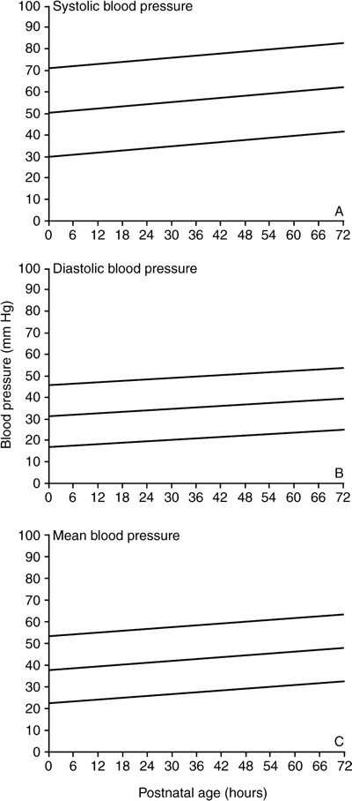
Name:____________________________________________ Class: ____________________
Date: _________________________________________________________________________________
□ EXERCISE 27 Questions to be Graded on simple Linear Regression
- 1. What are the independent and dependent variables in Figures 2, A, B, and C? How would you describe the relationship between the variables in Figures 2, A, B, and C?

- 2. What are the independent and dependent variables in Figures 3, A, B, and C? How would you describe the relationship between the variables in Figures 3, A, B, and C?

- 3. Was there a significant difference in the y intercept for the lines of best fit in Figure 2 from the y intercept for the lines of best fit in Figure 3? Provide a rationale for your answer.

- 4. Ŷ represents the predicted value of y calculated using the equation Ŷ = a + bx. In Figure 2, the formula for SBP is Ŷ = 43.2 + 0.17x. Identify the y intercept and the slope in this formula. What does x represent in this formula?

- 5. In the legend beneath Figure 2, the authors give an equation indicating that systolic blood pressure is SBP = 43.2 + 0.17x. If the value of x is postnatal age of 30 hours, what is the value for Ŷ or SBP for neonates ≤1,000 grams? Show your calculations.

- 6. In the legend beneath Figure 2, the authors give an equation indicating that systolic blood pressure is SBP = 50.3 + 0.12x. If the value of x is postnatal age of 30 hours, what is the value for Ŷ or SBP for neonates 1,001–1,500 grams? Show your calculations.

- 7. Compare the SBP readings you found in Questions 5 and 6. Explain the difference in these two readings.

- 8. In the legend beneath Figure 2, the authors give an equation indicating that diastolic blood pressure is DBP = 25.8 + 0.13x. If the value of x is postnatal age of 30 hours, what is the value for Ŷ for neonates ≤ 1,000 grams? Show your calculations.

- 9. In the legend beneath Figure 3, the authors give an equation indicating that diastolic blood pressure is DBP = 30.4 + 0.11x. If the value of x is postnatal age of 30 hours, what is the value for Ŷ for neonates 1,001–1,500 grams? Show your calculations.

- 10. In the legend beneath Figure 3, the authors give an equation indicating that diastolic blood pressure is DBP = 30.4 + 0.11x. How different is the DBP when the value of x is postnatal age of 60 hours versus the 30 hours examined in Question 9?

