Assignment 1
DQ 1
If we wish to have a 95% confidence interval, what would be the value of the confidence coefficient? [Hint: Table 4B]
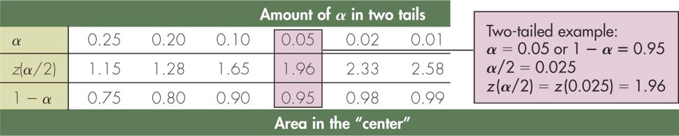
DQ 2
In your own words, describe the relationship between the standard error (of the mean) and maximum error.
The standard error is the standard deviation.
The maximum error is the product of the standard deviation and the z or t value
associated with the degree of confidence.

