9. The Morning Brew Coffee Shop sells Regular, Cappuccino, and Vienna blends of coffee. The shop’s current daily labor cost is $320, the equipment cost is $125, and the overhead cost is $225. Daily demands, along with selling price and material costs per beverage, are given below.
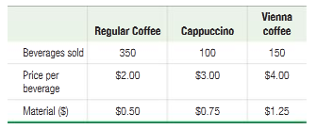
Harald Luckerbauer, the manager at Morning Brew Coffee Shop, would like to understand how adding Eiskaffee (a German coffee beverage of chilled coffee, milk, sweetener, and vanilla ice cream) will alter the shop’s productivity. His market research shows that Eiskaffee will bring in new customers and not cannibalize current demand. Assuming that the new equipment is purchased before Eiskaffee is added to the menu, Harald has developed new average daily demand and cost projections. The new equipment cost is $200, and the overhead cost is $350. Modified daily demands, as well as selling price and material costs per beverage for the new product line, are given below.
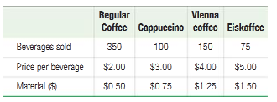
a. Calculate the change in labor and multifactor productivity if Eiskaffee is added to the menu.
b. If everything else remains unchanged, how many units of Eiskaffee would have to be sold to ensure that the multifactor productivity increases from its current level?

