- ) Suppose the market for watermelons can be described by the graph below.
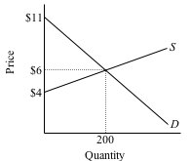

- If Jon's maximum willingness to pay for a watermelon is $8, how much surplus per unit is he receiving at the market price of $6?
- Suppose Figgy Farms requires at least $5 per watermelon before they will sell in this market. What is Figgy's producer surplus per unit in this market?
- How much total consumer surplus is received in this market?
- How much total producer surplus is received in this market?
- What is the combined surplus in the market?

