_________________________________________________________________
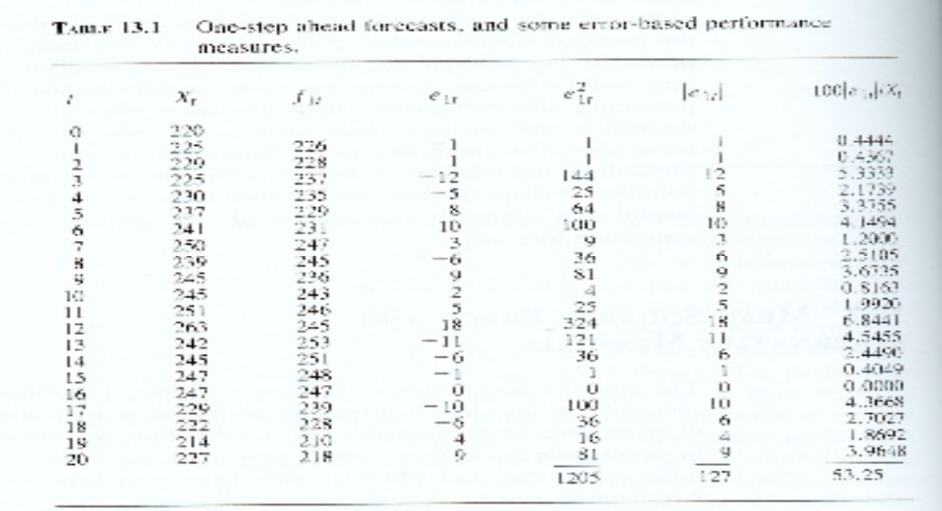a. using the table above plot a graph of predicted change against actual change

b. Find the sample correlation between predicted change and actual change

c. Fit by least squares the regression of actual change on predicted change

